

OpenL Tablets Reference Guide

OpenL Tablets 5.11
OpenL Tablets Rules Engine

Document number: TP_OpenL_Ref_2.1_SN

Revised: 09-10-2013

OpenL Tablets Documentation is licensed under a Creative Commons Attribution 3.0 United States License.

Table of Contents
Preface 6
Audience 6
Related Information 6
Typographic Conventions 6
Chapter 1: Introducing OpenL Tablets 8
What Is OpenL Tablets? 8
Basic Concepts 8
Rules 9
Tables 9
Projects 9
Wrappers 9
System Overview 10
Installing OpenL Tablets 11
Tutorials and Examples 11
Tutorials 11
Examples 13
Chapter 2: Creating Tables for OpenL Tablets 14
Table Recognition Algorithm 14
Table Properties 15
Category and Module Level Properties 15
Default Value 16
System Properties 16
Properties for Particular Table Type 16
Table Versioning 17
Info Properties 22
Dev Properties 23
Table Types 29
Decision Table 29
Datatype Table 43
Data Table 45
Test Table 50
Run Table 53
Method Table 54
Configuration Table 54
Properties Table 55
Spreadsheet Table 56
Column Match Table 60
TBasic Table 64
Table Part 64
Chapter 3: OpenL Tablets Functions and Supported Data Types 67
Arrays in OpenL Tablets 67
Array Index Operators 67
Rules Applied to Array 70
Working with Data Types 70
Simple Data Types 70
OpenL Tablets Data Types 73
Working with Functions 74
Understanding OpenL Function Syntax 74
Date Functions 75
ROUND function 77
Null Elements Usage in Calculations 80
Chapter 4: OpenL Business Expression Language 82
Java Business Object Model as Basis for OpenL Business Vocabulary 82
New Keywords, how to avoid possible naming conflicts 82
Simplifying Expressions with explanatory variables 83
Simplifying Expressions by Using Unique in Scope concept 83
OpenL Vocabulary and OpenL BEX 84
Future developments, compatibility etc 84
OpenL Programming Language Framework 84
OpenL Grammars 85
Context, Variables and Types 86
OpenL Type System 86
OpenL Tablets as OpenL Type extension 87
Operators 87
Binary Operators Semantic Map 88
Unary Operators 88
Cast Operators 88
Strict equality and relation operators 88
The list of org.openl.j Operators 88
The list of opg.openl.j Operator Properties 91
Chapter 5: Working With Projects 92
Project Structure 92
Creating a Project 93
Generating a Wrapper 93
Generating a Dynamic Wrapper 93
Using a Dynamic Wrapper in the Run-time Context 94
Generating a Static Interface 96
Generating a Static Wrapper 96
Example of Using a Static and Dynamic Wrapper 97
Rules Runtime Context 98
Using Rules Runtime Context in Java Code 100
Managing Rules Runtime Context from Rules 100
Module dependencies 102
Glossary 103
Functionality description 103
Components behavior 104
Appendix A: BEX Language Overview 106
Introduction to BEX 106
Keywords 106
Simplifying Expressions 107
Notation of Explanatory Variables 107
Uniqueness of Scope 107
Appendix B: Functions Used in OpenL Tablets 108
Math Functions 108
Array Functions 110
Date Functions 111
String Functions 112
Error Handling Functions 113
Index 114

Preface
This preface is an introduction to the OpenL Tablets Reference Guide.
The following topics are included in this preface:
- Audience
- Related Information
- Typographic Conventions

Audience
This guide is mainly intended for analysts and developers who create applications employing the table based decision making mechanisms offered by OpenL Tablets technology. However, other users can also benefit from this guide by learning the basic OpenL Tablets concepts described herein.
Basic knowledge of Excel® is desired to use this guide effectively. Basic knowledge of Java and Eclipse is desired to use some development related sections.

Related Information
The following table lists sources of information related to contents of this guide:
Related information
Title | Description
OpenL Tablets WebStudioUser's Guide | Document describing OpenL Tablets WebStudio, a web application for managing OpenL Tablets projects through web browser.
http://openl-tablets.sourceforge.net/ | OpenL Tablets open source project website.

Typographic Conventions
The following styles and conventions are used in this guide:
Typographic styles and conventions
Convention | Description
Bold | - Represents user interface items such as check boxes, command buttons, dialog boxes, drop-down list values, field names, menu commands, menus, option buttons, perspectives, tabs, tooltip labels, tree elements, views, and windows.  - Represents keys, such as F9 or CTRL+A.  - Represents a term the first time it is defined.
Courier | Represents file and directory names, code, system messages, and command-line commands.
Courier Bold | Represents emphasized text in code.
Select File > Save As | Represents a command to perform, such as opening the File menu and selecting Save As.
Italic | - Represents any information to be entered in a field.  - Represents documentation titles.
< > | Represents placeholder values to be substituted with user specific values.
Hyperlink | Represents a hyperlink. Clicking a hyperlink displays the information topic or external source.

Chapter 1: Introducing OpenL Tablets
OpenL TabletsThis section introduces OpenL Tablets and describes its main concepts.
The following topics are included in this section:
- What Is OpenL Tablets?
- Basic Concepts
- System Overview
- Installing OpenL Tablets
- Tutorials and Examples

What Is OpenL Tablets?
OpenL TabletsOpenL Tablets is a Business Rules Management System (BRMS) and Business Rules Engine (BRE) based on tables presented in Excel documents. Using unique concepts, OpenL Tablets facilitates treating business documents containing business logic specifications as executable source code. Since the format of tables used by OpenL Tablets is familiar to business users, OpenL Tablets bridges a gap between business users and developers, thus reducing costly enterprise software development errors and dramatically shortening the software development cycle.
In a very simplified overview, OpenL Tablets can be considered as a table processor that extracts tables from Excel documents and makes them accessible from Java programs.
OpenL Tablets is built using the OpenL technology providing a framework for development of different language configurations.
OpenL TabletsThe major advantages of using OpenL Tablets are as follows:
- OpenL Tablets removes the gap between software implementation and business documents, rules, and policies.
- Business rules become transparent to Java developers.
For example, rule tables are transformed into Java methods, and data tables become accessible as Java data arrays through the familiar getter and setter JavaBeans mechanism. The transformation is performed automatically.
- OpenL Tablets verifies syntax and type errors in all project document data, providing convenient and detailed error reporting.
- OpenL Tablets is able to directly point to a problem in an Excel document.
- OpenL Tablets provides calculation explanation capabilities, enabling expansion of any calculation result by pointing to source arguments in the original documents.
- OpenL Tablets provides cross-indexing and search capabilities within all project documents.
OpenL Tablets supports the .xls, .xlsx, .xlsm file formats.

Basic Concepts
OpenL TabletsThis section describes the following main OpenL Tablets concepts:
- Rules
- Tables
- Projects
- Wrappers

Rules
OpenL TabletsIn OpenL Tablets, a rule is a logical statement consisting of conditions and actions. If a rule is called and all its conditions are true then the corresponding actions are executed. Basically, a rule is an IF-THEN statement. The following is an example of a rule expressed in human language:
If a service request costs less than 1,000 dollars and takes less than 8 hours to execute then the service request must be approved automatically.
Instead of executing actions, rules can also return data values to the calling program.

Tables
OpenL TabletsBasic information OpenL Tablets deals with, such as rules and data, is presented in tables. Different types of tables serve different purposes. For detailed information on table types, see Table Types.

Projects
OpenL TabletsOpenL TabletsAn OpenL Tablets project is a container of all resources required for processing rule related information. Usually, a project contains Excel or and optionally Java code, library dependencies, Ant task for generating wrappers of table files. For detailed information on projects, see Chapter 5: Working with Projects.
There can be situations where OpenL Tablets projects are used in the development environment but not in production, depending on the technical aspects of a solution.

Wrappers
OpenL TabletsA wrapper is a Java class that exposes decision tables as Java methods, data tables as Java objects and allows developers to access table information from code. To access a particular table from Java code, a wrapper Java class must be generated for the Excel file where the table is defined. Wrappers are essential for solutions where compiled OpenL Tablets project code is embedded in solution applications. If tables are accessed through web services, client applications are not aware of wrappers but they may be still used on the server.
Wrappers can be dynamic or static as described in the following table:
Wrapper types
Type | Description
Dynamic | For a dynamic wrapper, only a rule interface must be defined upon project creation. The rules run-time factory provides instances implementing this interface in run-time.  Using dynamic wrappers, and not the static wrappers, is recommended.
Static | The wrapper Java class is generated in a rule project for a static wrapper, which contains all OpenL Tablets API usage logic to call rules.
Using dynamic wrappers, rather than static wrappers, is more advantageous as it enables OpenL Tablets users to clearly define the rules displayed in the application. Using a static wrapper can be inconvenient in that a wrapper must be regenerated each time a new version of OpenL Tablets is released.
OpenL Tablets provides a specific Ant task that can be used for static generation of a wrapper from any Excel file automatically.
A static wrapper class must be regenerated in the following situations:
- A table signature, such as method name, input parameters, and return values, is modified.
- A table is added or deleted in the corresponding file.
Wrapper classes do not have to be regenerated if table data is modified or if conditions and actions are added or removed.
For more information on generating wrappers, see Generating a Wrapper.

System Overview
The following diagram shows how OpenL Tablets is used by different types of users:
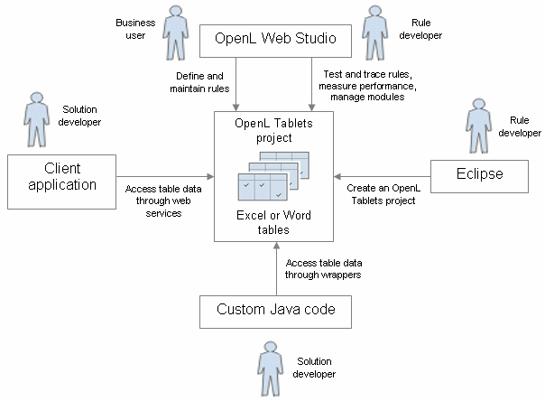

Figure 1: OpenL Tablets overview
The following is a typical lifecycle of an OpenL Tablets project:
- A rule developer creates a new OpenL Tablets project in Eclipse.
- In addition to the project itself, the rule developer also creates correctly structured tables in Excel files based on requirements and includes them in the project.
- A business user accesses tables in the OpenL Tablets project and defines rules.
Typically, this task is performed through OpenL Tablets WebStudio in a web browser.
- A rule developer performs unit tests and performance tests on rules through advanced OpenL Tablets WebStudio features.
- A developer who creates other parts of the solution employs business rules directly through the OpenL Tablets engine or remotely through web services.
- Whenever required, the business user updates or adds new rules to project tables.

Installing OpenL Tablets
OpenL TabletsOpenL Tablets development environment is installed as an Eclipse update site. The installation process of the OpenL Tablets feature is the same as for any other Eclipse feature. Refer to OpenL Tablets Installation Guide for installation details.
The development environment is required only for creating OpenL Tablets projects and launching OpenL Tablets WebStudio. If ready OpenL Tablets projects are accessed through OpenL Tablets WebStudio or web services, no specific software needs to be installed.

Tutorials and Examples
OpenL Tablets provides a number of preconfigured projects intended for new users who want to learn working with it quickly.
These projects are organized into following groups:
- Tutorials
- Examples

Tutorials
OpenL Tablets provides a set of tutorial projects demonstrating basic OpenL Tablets features beginning very simply and moving on to more advanced projects. Files in the tutorial projects contain detailed comments allowing new users to grasp basic concepts quickly.
To create a tutorial project, proceed as follows:
- In OpenL Tablets WebStudio, click the Repository item in the top line menu to open the Repository Editor.
- Click the Create Project button: .
- In the Create Project from dialog, navigate to the desired tutorial and click its name.
- Click the Create button to complete. The project appears in the Projects list of the Repository Editor.
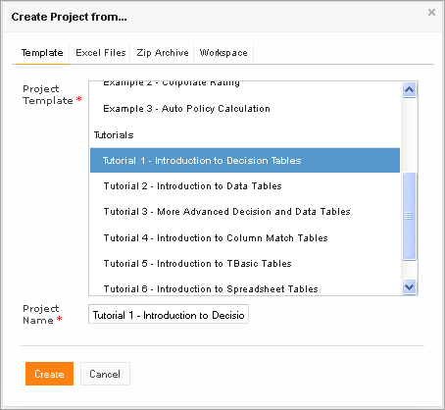
Figure 2: Creating tutorial projects
- Click Rules Editor in the top line menu. The project is displayed in the Projects list and available for usage.
We highly recommend you to start from reading Excel files for Examples /Tutorials since they provide clear explanations for every step involved.
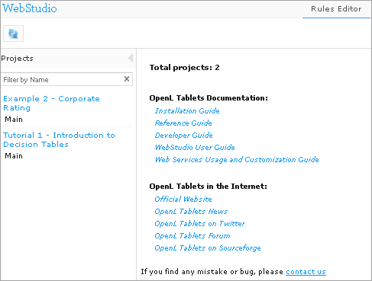

Figure 3: Tutorial project in the OpenL Tablets WebStudio

Examples
In addition to tutorials, OpenL Tablets provides several example projects that demonstrate how OpenL Tablets can be used in various business domains.
To create an example project, follow the steps described in the Tutorials section, just the Create Project from dialog locate an example you wish to use. After you complete the example appears in the WebStudio Rules Editor as shown in the Figure 3.

Chapter 2: Creating Tables for OpenL Tablets
OpenL TabletsThis section describes how OpenL Tablets processes tables and provides reference information for each table type used in OpenL Tablets.
The following topics are included in this section:
- Table Recognition Algorithm
- Table Properties
- Table Types

Table Recognition Algorithm
This section describes the algorithm of how the OpenL Tablets engine looks for supported tables in Excel files. It is important to build tables according to requirements of this algorithm; otherwise the tables will not be recognized correctly.
OpenL Tablets utilizes Excel concepts of workbooks and worksheets. These can be represented and maintained in multiple Excel files. Each workbook is comprised of one or more worksheets used to separate information by categories. Each worksheet, in turn, is comprised of one or more tables. Workbooks can include tables of different types, each of which can support a different underlying logic.
The following is the general table recognition algorithm:
- The engine looks into each spreadsheet and tries to identify logical tables.
Logical tables must be separated by at least one empty row or column or start at the very first row or column. Table parsing is performed from left to right and from top to bottom. The first populated cell that does not belong to a previously parsed table becomes the top-left corner of a new logical table.
- The engine reads text in the top left cell of a recognized logical table to determine its type.
If the top left cell of a table starts with a predefined keyword then such table is recognized as an OpenL Tablets table.
The following are the supported keywords:
Table type keywords
Keyword | Table type
Rules | Decision Table
Data | Data Table
Datatype | Datatype Table
Test | Test Table
Run | Run Table
Method | Method Table
Environment | Configuration Table
Properties | Properties Table
Spreadsheet | Spreadsheet Table
ColumnMatch | Column Match Table
TBasic or Algorithm | TBasic Table
SimpleRules | SimpleRules Table
SimpleLookup | SimlpeLookup Table
TablePart | Table Part
All tables that do not have any of the preceding keywords in the top left cell are ignored. They can be used as comments in Excel files.
- The engine determines the width and height of the table using populated cells as clues.
It is good practice to merge all cells in the first table row, so the first row explicitly specifies the table width. The first row is called the table header.
Tip: To put a table title before the header row, an empty row must be used between the title and the first row of the actual table.

Table Properties
For all OpenL Tablets table types, except for Properties Table, Configuration Table and the Other type tables (not OpenL Tablets tables), properties can be defined as containing information about the table. A list of properties available in OpenL Tablets is predefined, and all values are expected to be of corresponding types. The exact list of available properties can vary between installations depending on OpenL Tablets configuration.
Table properties are displayed in the section which goes immediately after the table header and before other table contents. The properties section is optional and can be omitted in the table. The first cell in the properties row contains keyword “properties” and is merged across all cells in column if more than one property is defined. The number of rows in the properties section is equal to number of properties defined for the table. Each row in the properties section contains a pair of a property name and a property value in consecutive cells (2nd and 3rd columns).
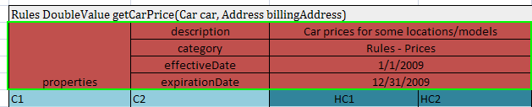

Figure 4: Table properties example

Category and Module Level Properties
Table properties can be defined not only for each table separately, but for all tables in some category or a whole module. Separate Properties Table is designed to define this kind of properties. Only properties which are allowed to be inherited from category and/or module level can be defined in this table. Some properties, e.g., description, can only be defined for a table.
Properties defined at a category or module level can be overridden in tables. The priority of property values is following:
- Table
- Category
- Module
- Default value
Notice: OpenL Tablets engine allows changing property values from application code when loading rules.

Default Value
Some properties can have default values. The value is predefined and can be changed only in OpenL Tablets configuration. The default value is used if no property value is defined in the rule table or in the Properties table.
Properties defined by default are not added to the table's “properties” section and can only be changed in the right side Properties pane.

System Properties
System properties can only be set and updated by OpenL Tablets, not by the users. Currently OpenL Tablets WebStudio defines the following system properties: Created By / Created On and Modified By / Modified On (For details refer to User's GuideOpenL Tablets WebStudio).

Properties for Particular Table Type
There are properties to be used just for particular types of tables. It means that they make sense just for tables with special type and can be defined only for them. Almost all properties can be defined for Decision Tables except for the ‘Datatype Package’ property intended for Datatype Tables, the ‘Scope’ property used in Properties Tables and ‘Precision’ property designed for Test Tables.
OpenL Tablets checks applicability of properties and will produce error if property value is defined for table not intended to contain the property.
Applications using OpenL Tablets rules can utilize properties for different purposes. All properties are organized into the following groups:
- Business Dimension
- Version
- Info
- Dev
Properties of the Business Dimension and Version groups are used for table versioning. They are described in details in the following sections.

Table Versioning
In OpenL Tablets business rules can be versioned in different ways using Table properties. In this section we will consider the most popular of them:
- Business Dimension properties
- Active table properties
The first way is targeting advanced rules usage when several rule sets are used simultaneously; it is more extendable and flexible. The second way is more suitable for “what-if” analysis. Versioning by Business Dimension properties is described in the next section. Active table properties are discussed further in this document.

Business Dimension Properties
The properties of the “Business Dimension” group are used to version rules by property values. You will usually want to use this type of versioning if there are rules with the same “meaning”, but applied in different conditions. You can have in your project as many rules with the same name as you need; the system will select and apply the desired rule by its properties. E.g. calculating employees’ salary for different years can vary by some coefficients, have slight changes in the formula, or the both. In this case using Business Dimension properties enables you for every year apply appropriate rule version and get proper results.
The following table types support versioning by Business Dimension properties
- Decision (including SimpleRules and SimpleLookup)
- Spreadsheet
- TBasic
- Method
- ColumnMatch
If you deal with almost equal rules of the same structure but with slight differences – say, with changes in any specific date or state, – there is a very simple way to version your rule tables by Business Dimension properties. Just follow these steps:
- Take the original rule table, set any dimension properties that indicate by which property you want to version the rules (it is possible to use more than one property).
- Copy your original rule table, set new dimension properties for this table, and make changes in the table data as appropriate.
- Repeat these steps if more rule versions are required.
Now you can call your rule by its name from any place in your project or application. Although you have multiple rules with the same name (but different Business Dimension properties), you should not worry about which rule will work. OpenL Tablets will review all the rules and choose the corresponding one according to the specified property values (or in developers’ language, by runtime context values).
The table below contains a list of Business Dimension properties used in OpenL Tablets.
Property | Name to be used  in rule tables | Level at which a property can be defined | Type | Description
Effective / Expiration dates | effectiveDate  expirationDate | Module, Category, Table | Date | Defines a time interval within which a rule table is active. The table becomes active on effective date and inactive after the expiration date. You can have multiple instances of the same table in the same module with different effective/expiration date ranges.
Start / End Request dates | startRequestDate  endRequestDate | Module, Category, Table | Date | Defines a time interval within which a rule table is introduced in the system and is available for usage.
LOB (Line of Business) | lob | Module, Category, Table | String | Defines a LOB for a rule table - a business area for which the given rule works and should be used.
US Region | usregion | Module, Category, Table | Enum[] | Defines US region.
Countries | country | Module, Category, Table | Enum[] | Defines countries.
Currency | currency | Module, Category, Table | Enum[] | Defines currency.
Language | lang | Module, Category, Table | Enum[] | Defines language.
US States | state | Module, Category, Table | Enum[] | Defines US States.
Region | region | Module, Category | Enum[] | Defines economic region.

Note: For experienced users. There is a possibility of direct call of particular rule regardless of its dimension properties and current Runtime Context in OpenL Tablets. This feature is supported by setting the ID property (see the Dev Properties section for description) in some rule and using this identifier as the name of the function to call. During runtime, direct rule will be executed avoiding the mechanism of dispatching between overloaded rules.
Further in this section we provide illustrative and very simple examples of how to use Business Dimension properties.

Effective and Expiration Date
The following Business Dimension properties are intended for versioning business rules depending on some specific dates:
- Effective Date is the date as of which a business rule comes into effect and produces desired and expected results.
- Expiration Date is the date after which your rule is no longer applicable. If not defined, the rule works at any time on or after the Effective Date.
NOTE: If Expiration Date is not defined, the rule works at any time on or after the Effective Date.
The date for which the rule should be performed must fall into the Effective/ Expiration date time interval.
You can have multiple versions of the same rule table in the same module with different Effective/Expiration date ranges. But these dates cannot overlap with each other – i.e. if in one version of the rule your Effective/Expiration dates are 1.2.2010 – 31.10.2010, you should not create another version of that rule with Effective/Expiration dates within this dates frame.
For our example, we will take a rule for calculating a car insurance premium Quote. The rule is completely the same for different time periods except for some coefficient – a Quote Calculation Factor (hereinafter the ‘Factor’). This factor is defined for each model of car.
In the examples below we will show how these properties enable you to specify which rule to apply for a particular date.
We will assume that you have a business rule for calculating the Quote for 2011 shown in the Figure 5. The Effective Date is 1/1/2011 and the Expiration Date is 12/31/2011.
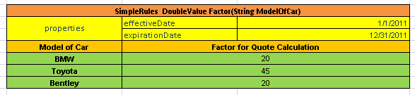
Figure 5: Business rule for calculating a car insurance quote for 2011 year
However, we cannot use this rule for calculating the quote for 2012 year because the Factors for the cars differ from the previous year.
The rules name and their structure are the same but with different values of the Factor. Then it is a good idea to use versioning in the rules.
To create the rule for 2012 year:
- Copy your rule table. In OpenL Tablets WebStudio, you can do it using the Copy as New Business Dimension feature (See the Copying Tables section in the OpenL Tablets WebStudio User Guide).
- Change your Effective and Expiration date to 1/1/2012 and 12/31/2012 respectively.
- Replace the Factors as appropriate for 2012 year.
Your new table will look as shown in the Figure 6.
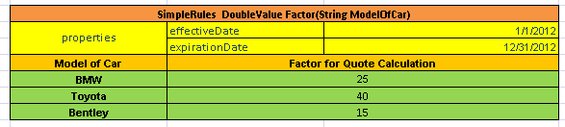
Figure 6: Business rule for calculating the same quote for 2012 year
To check how your rules work, let’s test them for a certain car model and for particular dates, say, 10/5/2011 and 11/2/2012. The result of the test for BMW is shown in the Figure 7.
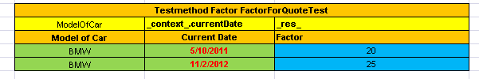
Figure 7: Selection of the Factor based on Effective / Expiration Dates
In this example, the date on which you should to perform calculation (on client’s requirement) is shown in the Current Date column. In the first row for BMW, the Current Date is 10/5/2011, and since 10/5/2011> 1/1/2011 and 10/5/2011< 12/31/2011, the Factor for this date is ‘20’.
In the second row, the Current Date is 11/2/2012, and since 11/2/2012> 1/1/2012 and 11/2/2012< 12/31/2012, the Factor is 25.

Using Request Date
In some cases it is necessary to define additional time intervals for which your business rule is applicable. There are another two Table properties related to dates which can be used for selecting applicable rules. These properties have different meaning and work with slightly different logic compared to previous ones.
- Start Request Date is the date when your rule is introduced in the system and is available for usage.
- End Request Date is the date from which the system will not use the rule. If not defined, the rule can be used any time on or after the Start Request Date.
The date, when the rule is applied must be within the Start / End Request Date time interval. In OpenL Tablets rules this date is defined as a ‘Request Date’.
NOTE: Pay attention to the difference between previous two properties: Effective / Expiration dates have meaning for what date your rules are applied. In contrast, Request dates mean when your rules are used (called from application).
You can have multiple rules with different Start /End Request dates, but being intersected in dates. In this case, the system will select the rule with the latest Start Request date. If there are rules with the same Start Request date OpenL Tablets will choose the rule with the earliest End Request date. And only in the case when Start /End Request dates coincide completely the system will show an error message.
NOTE: You cannot create a rule table version with exactly the same Start Request Dates or End Request Dates, because it will cause an error message.
NOTE: In some particular cases, Request Date is used to define the date when your business rule was called at the very first time.
Let's take another example where the additional date properties are defined: Start Request Date and End Request Date.
To demonstrate how these dates work, we will use the same rule for calculating a car insurance quote. But for some reason, you should enter the rule for 2012 year into the system in advance, say, from 12/1/2011. For that you can add to the rule the Start Request Date = 12/1/2011as shown in the Figure 8. Adding this property tells OpenL Tablets the system can use the rule from the given Start Request date.
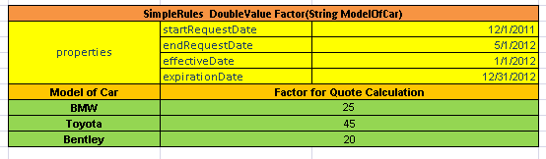
Figure 8: The rule for calculating the Quote is introduced from 12/1/2011
And let’s assume that then you introduced a new rule with different Factors from 2/3/2012 as shown in the Figure 9.
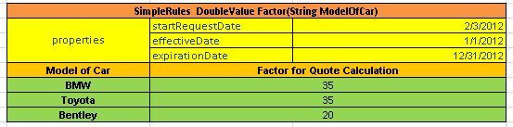
Figure 9: The rule for calculating the Quote is introduced from2.3.2011
However, the US legal regulations require you to use the same rules for premium calculations so you will need to stick to previous rules for older policies. In this case storing Request Date in application helps to solve the issue. By provided Request Date, OpenL Tablets will be able to choose rules available in the system on the designated date.
When you test your rules for BMW for particular request dates and effective dates, you will have the following result shown in the Figure 10:
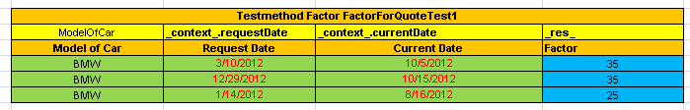
Figure 10: Selection of the Factor based on Start / End Request Dates
In this example, the dates for which the calculation is performed, are displayed in the Current Date column. The dates when you run your rule and perform the calculation is shown in the Request Date column.
Please pay attention on the row where Request Date is 3/10/2012 – this date falls in the both Start /End Request date intervals shown in Figures 8 and 9. But Start Request date in Figure 9 is later than the one defined in the rule from Figure 8. As a result, correct Factor value is 35.
So by using different sets of Business Dimension Properties you can flexible version your rules with keeping all of them in the system.
OpenL Tablets runs validation to check gaps and overlaps of properties values for versioned rules.

Active Table
Table versioning enables to store the previous versions of the same table of the rule in the same rules file. The active table versioning mechanism is based on two properties “version” and “active”. The “version” property should be different for each table and only one of them can have true as value for the “active” property.
All table versions should have the same identity that is exactly the same signature and dimensional properties values. Also table types should be the same.
An example of an inactive table version is as follows:
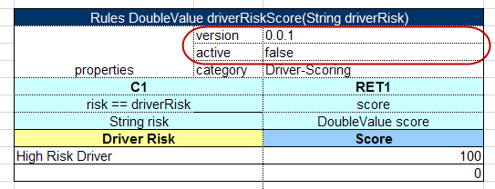

Figure 11: An inactive table version

Info Properties
The Info group includes properties that provide any useful information; this group enables users to easily read and understand rule tables.
The table below provides a list of Info properties along with their brief description.
Property | Name to be used  in rule tables | Level at which property can be defined and overridden | Type | Description
Category | category | Category, Table | String | The category of the table. By default, is equal to the name of the Excel sheet where the table is located. If the property level is specified as ‘Table’, defines category for the current table. Must be specified if scope is defined as ‘Category’ in a Properties table.
Description | description | Table | String | Description of a table, e.g. ‘Car price for a particular Location/Model.’ Any additional information to clarify the use of the table.
Tags | tags | Table | String[] | Can be used for search; there can be any number of comma-separated tags.
Created By | createdBy | Table | String | A name of a user created the table in OpenL Tablets WebStudio.
Created On | createdOn | Table | Date | Date of the table creation in OpenL Tablets WebStudio.
Modified By | modifiedBy | Table | String | A name of a user last modified the table in OpenL Tablets WebStudio.
Modified On | modifiedOn | Table | Date | The date of the last table modification in OpenL Tablets WebStudio.

Dev Properties
The Dev group has an impact on the OpenL Tablets features and enables to manage the system behavior depending on a property value. For example, the Scope property defines whether the properties are applicable for a particular Category of rules or for the Module. If Scope is defined as Module, the properties will be applied for all tables in the current module. If Scope is defined as Category, then you should use the Category property to specify for which exact category the property is applicable, as shown in the Figure 12.
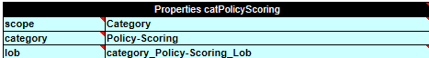
Figure 12 : The properties are defined for the ‘Police-Scoring’ category
The Dev group properties are listed in the following table.
Property | Name to be used  in rule tables | Type | Table type | Level at which property can be defined | Description
ID | id | Table | All | Table | The property defines unique ID to be used for calling a particular table in a set of overloaded tables without using business dimension properties. NOTE: Constraints for the ID value are the same as for any OpenL function.
Build Phase | buildPhase | String | All | Module, Category, Table | The property is used to manage dependencies between build phases. NOTE: Will be used in future versions.
Validate DT | validateDT | String | Decision Table | Module, Category, Table | The property specifies the validation mode for Decision Tables. In a wrong case an appropriate warning is issued.Possible values:  on – checks if there are any uncovered or overlapped cases;  off — the validation is turned off;  gap – checks if there are uncovered cases;  overlap - checks if there are overlapped cases.
Fail On Miss | failOnMiss | Boolean | Decision Table | Module, Category, Table | The property defines a rule behavior in case no rules were matched. If the property is set to TRUE an error occurs along with the corresponding explanation. If FALSE, the table output is set to NULL.
Scope | scope | String | Properties | Module, Category | The property defines the scope for a Properties table.
Datatype Package | datatypePackage | String | DataType | Table | The property defines the name of the Java package for generating the datatype.
Recalculate | recalculate | Enum |  | Module, Category, Table | The property defines the way of a table recalculation for a variation. Possible values: Always/Never/Analyze.
Cacheable | cacheable | Boolean |  | Module, Category, Table | The property defines whether or not to use cache while recalculating the table, depending on the rule input.
Precision | precision | Integer | Test Table | Module, Category, Table | The property specifies precision of comparing the returned results with expected ones while launching Test Tables.

Variation Related Properties
This section provides more information about variations and the properties required to work with them, namely — Recalculate and Cacheable.
A variation means “An additional calculation of the same rule with a modification in its arguments”. Variations are very useful when you need to calculate a rule several times with similar arguments. The idea of this approach is to calculate once the rules for a particular set of arguments and then recalculate only the rules or steps that depend on the specifically modified (by variation) fields in those arguments.
The following Dev properties are designed to manage rules recalculation for variations.
- Cacheable — The property switches on/off using cache while recalculating the table. Can be evaluated to true or false. If true, the all calculation results of the rule will be cached and can be used in other variations, otherwise calculation results will not be cached. It’s recommended to set Cacheable to true if you suggest recalculating a rule with the same input parameters. In this case OpenL does not recalculate the rule; instead, it retrieves the results from the cache.
- Recalculate — The property explicitly defines the recalculation type of the table for a variation. It can take the following values: always, never or analyze.
If the Recalculate property is set to Always for a rule, the rule will be entirely recalculated for a variation. This value is useful for rule tables which are supposed to be recalculated.
If the Recalculate property is set to Never for a rule, the system will not recalculate the rule for a variation. You can set it for rules which new results you are not interested in and which are not necessary for a variation.
As for the Analyze value, it should be used for top level rule tables to ensure recalculation of the included rules with the Always value. The included table rules with the Never value will be ignored.
By default, the properties are set as follows:
recalculate = always;
cacheable = false.
To provide an illustrative example of how to use Variation Related Properties, we will take the Spreadsheet rule DwellPremiumCalculation (see the figure below) which calculates a home insurance premium Quote. The quote includes calculations of Protection and Key factors which values are dependent on Coverage A limit (see ProtectionFactor and KeyFactor simple rules). The insurer wants to vary Coverage A limit of the Quote and observe how limit variations impact on Key factor exactly.
The DwellPremiumCalculation is a top level rule and during recalculation of the rule we are interested in some of the results only. That’s why we should define recalculation type (the “recalculate” property) as Analyze for this rule.
As the interest of the insurer is to get a new value of Key factor for a new Coverage A limit value, recalculation type of the KeyFactor rule should be determined as Always.
On the contrary, Protection factor is not interesting for the insurer, so the ProtectionFactor rule is not required to be recalculated. To optimize the recalculation process, recalculation type of the rule should be set up as Never. Moreover, other rules tables like the BaseRate rule which are not required to be recalculated should have “recalculation” property as Never too.
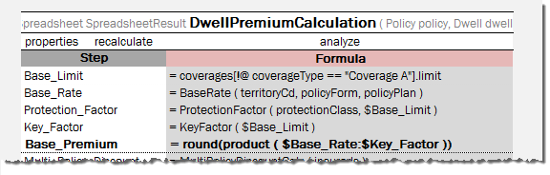
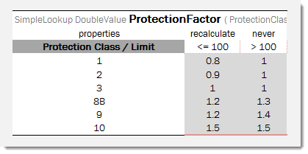
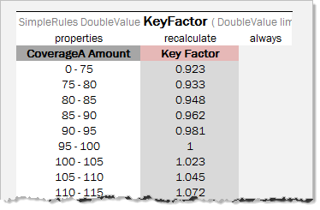

Figure 13: Usage of Variation Related Properties
Let Coverage A limit of the quote is 90, Protection Class is 9. A modified value of Coverage A limit for a variation is going to be 110. Then the following Spreadsheet results (after the first calculation and the second recalculation) are obtained:
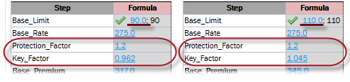

Figure 14: Results of DwellPremiumCalculation with recalculation = Analyze
You can notice that Key factor is recalculated, but Protection factor remains the same (Protection factor of initial Coverage A limit).
If you define recalculation type of DwellPremiumCalculation as Always, OpenL Tablets will ignore (will not analyze) recalculation types of nested rules and recalculate all cells as shown on the figure below:
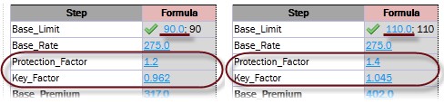

Figure 15: Results of DwellPremiumCalculation with recalculation = Always

Precision Property usage in Testing
This section provides more information about how to use precision property. The property is aimed to be used for testing purpose.
There are some cases when it is impossible or not needed to define exact numeric value of an expected result in Test Tables. For example, non-terminating rational numbers such as π (3.1415926535897…) must be approximated so that it could be written in a cell of a table.
Property Precision is used as a measure of the accuracy of the expected value to the returned value to a certain precision. Let’s precision of the expected value A is N. Then expected value A is true only if
|A – B| < 1/10^{N}, where B – returned value.
It means that if the expected value is close enough to the returned value then the expected value is considered to be true.
Let’s look at the following examples. A simple rule FinRatioWeight has 2 tests FinRatioWeightTest1 and FinRatioWeightTest2:
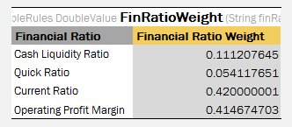

Figure 16: An example of Simple Rule
The first Test table has Precision property defined with value 5:
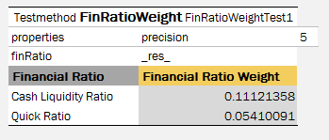
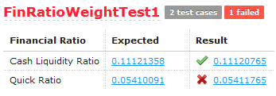

Figure 17: An example of Test with precision defined
As a result of launching this Test, the first test case is passed because |0.11121358 - 0.111207645| = 0.5935*10⁻⁵ < 0.00001; but the second is failed because |0.05410091 - 0.054117651| = 1.6741*10⁻⁵ > 0.00001.
OpenL Tablets allows us to specify precision for a particular column which contains expected result values using syntax
_res_ (N) or _res_.$<ColumnName>$<RowName> (N)
as it’s shown in the second test table FinRatioWeightTest2:
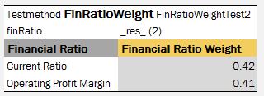

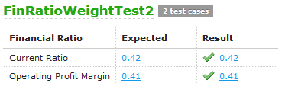

Figure 18: An example of Test with precision for the column defined
This possibility is required in cases when the results of the whole Test are taking into account with one accuracy, but some separate expected results – with others.
A precision defined for the column has higher priority than a precision defined at the Table level.
Precision can be zero or a negative value also (any Integer value).

Table Types
OpenL Tablets employs the following table types:
- Decision Table
- Datatype Table
- Data Table
- Test Table
- Run Method Table
- Method Table
- Configuration Table
- Properties Table
- Spreadsheet Table
- Column Match Table
- TBasic Table
- Table Part

Decision Table
A decision table contains a set of rules describing decision situations where the state of a number of conditions determines the execution of a set of actions. It is the basic table type used in OpenL Tablets decision making.
The following topics are included in this section:
- Decision Table Structure
- Lookup Tables
- Simple Decision Tables
- Decision Table Interpretation
- Local Parameters in Decision Table
- Transposed Decision Tables
- Representing Arrays
- Representing Date Values
- Representing Boolean Values
- Ranges types in OpenL
- Using Calculations in Table Cells

Decision Table Structure
The following is an example of a decision table:
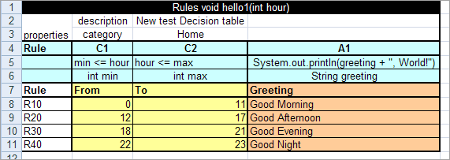

Figure 19: Decision table
The following table describes its structure:
Decision table structure
Row number | Mandatory | Description
1 | Yes | Table header, which has the following pattern:  <keyword> <rule header>  where <keyword> is either 'Rules' or 'DT' and <rule header> is a signature of a method used to access the decision table and provide input parameters.  For example, the table in the preceding diagram can be invoked as follows:  HelloWrapper tableWrapper = new HelloWrapper();  tableWrapper.hello1(15);  where HelloWrapper is the wrapper class of the Excel file. For general information on wrappers, see Wrappers.
2 and 3 | No | Rows containing table properties. Each application using OpenL Tablets rules can utilize properties for different purposes..  Although the provided decision table example contains two property rows, there can be any number of property rows in a table.
4 | Yes | Row consisting of the following cell types:  All other cells in this row are ignored and can be used as comments.  If a table contains action columns, the engine executes actions for all rules whose conditions are true. If a table has a return column, the engine stops processing rules after the first executed rule. If a return column has a blank cell and the rule is executed, the engine does not stop but continues checking rules in the table.
  Type | Description | Examples
  Condition column header | Identifies that the column contains rule condition and its parameters. It must start with character 'C' followed by a number. | C1, C5, C8
  Horizontal condition column header | Identifies that the column contains horizontal rule condition and its parameters. It must start with character 'HC' followed by a number.  Horizontal conditions are used in lookup tables only. | HC1, HC5, HC8
  Action column header | Identifies that the column contains rule actions. It must start with character 'A' followed by a number. | A1, A2, A5
  Return value column header | Identifies that the column contains values to be returned to the calling program. A table can have multiple return columns, however, only the first fired not blank value is returned. | RET1
5 | Yes | Row containing cells with code statements for condition, action, and return value column headers. OpenL Tablets supports Java grammar enhanced with OpenL Business Expression (BEX) grammar features. For information on the BEX language, see Appendix A: BEX Language Overview.  Code in these cells can use any Java objects and methods visible to the OpenL Tablets engine. For information on enabling the OpenL Tablets engine to use custom Java packages, see Configuration Table.  Purpose of each cell in this row depends on the cell above it as follows:
  Cell above | Purpose
  Condition column header | Specifies the logical expression of the condition. It can reference parameters in the method header and parameters in cells below.  The cell can contain several expressions, but the last expression must return a Boolean value. All condition expressions must be true to execute a rule.
  Horizontal condition | The same to Condition column header.
  Action column header | Specifies code to be executed if all conditions of the rule are true. The code can reference parameters in the rule header and parameters in cells below.
  Return value column header | Specifies expression used for calculating the return value. The type of the last expression must match the return value specified in the rule header. The explicit return statement is also supported.  This cell can reference parameters in the rule header and parameters in cells below.
6 | Yes | Row containing parameter definition cells. Each cell in this row specifies the type and name of parameters in cells below it.  Parameter name must be one word corresponding to Java identification rules.  Parameter type must be one of the following:  - primitive Java types  - Java classes visible to the engine  - one-dimensional arrays of the above types as described in Representing Arrays  - data tables or their attributes as described in Using Advanced Data Tables
7 | Yes | Descriptive column titles. The rule engine does not use them in calculations but they are intended for business users working with the table. Cells in this row can contain any arbitrary text and be of any layout that does not correspond to other table parts. The height of the row is determined by the first cell in the row.
8 and below | Yes | Concrete parameter values.

Lookup Tables
Lookup table is a special modification of Decision table which simultaneously contains vertical and horizontal conditions and returns value on crossroads of matching condition values.
That means condition values could appear either on the left of the lookup table or on the top of it. The values on the left are called "vertical" and values on the top are called "horizontal".
The Horizontal Conditions are marked as HC1, HC2, etc. Every lookup matrix should starts from HC or RET column. The first HC or RET column should go after all vertical conditions (C, Rule, comment, etc columns). RET section can be placed in any place of lookup headers row. HC columns do not have Titles section.
Lookup table must have:
- at least one vertical condition (C)
- at least one horizontal condition (HC)
- exactly one return column (RET)
Lookup table can have:
- Rule column
Lookup table cannot have comment column!
Advanced usage:
- Lookup table (in theory) might have vertical Actions which will be processed the same way as vertical conditions.
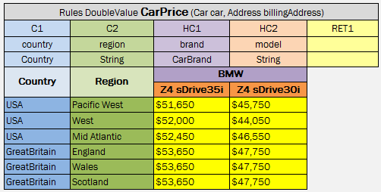

Figure 20: A lookup table example
Colors identify how values are related to conditions. The same table represented as a decision table follows:
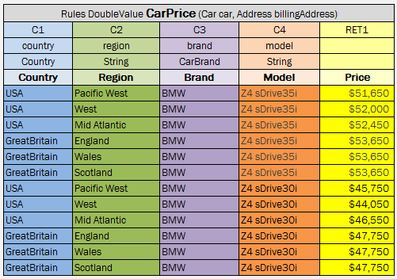

Figure 21: Lookup table representation as a decision table

Implementation Details
(Just for your information. This passage can be interesting to understand internal OpenL Tablets logic.)
At first the table goes through parsing and validation. On parsing all parts of the table such as header, columns headers, vertical conditions, horizontal conditions, return column and their values are extracted. On validation OpenL checks if the table structure is proper.
To work with this kind of table TransformedGridTable object is created as constructor parameters it has in original grid table of lookup table (without header) and the CoordinatesTransformer that converts table coordinates to work with both vertical and horizontal conditions.
As the result we get a GridTable and works with it as a decision table structure, all coordinates transformations with lookup structure goes inside. Work with columns/rows is based on physical (not logical) structure of the table.

Simple Decision Tables
Practice shows that most of decision tables have simple structure: there are conditions for each input parameter of a decision table (that check equality of input and condition values) and a return column. Because of this fact, OpenL Tablets have a simplified decision table representation. Simple decision table allows skipping condition and return columns declarations, and the table will consist of a header, properties (optional), column titles and condition/return values. The only restriction for a simple decision table is that condition values must be of the same type as input parameters and return values must have the type of the return type from the decision table header.

Simple Rules Table
Usual decision table which has simple conditions for each parameter and simple return can be easily represented as SimpleRules table.

Header format:
SimpleRules <Return type> ruleName(<Parameter type 1> parameterName1, (<Parameter type 2> parameterName 2….)

SimpleRules Table Example
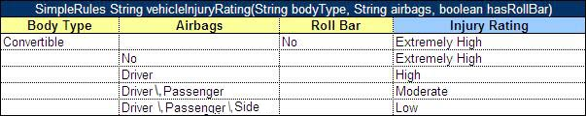

Figure 22: SimpleRules table example

SimpleLookup Table
Usual lookup decision table with simple conditions that check equality of an input parameter and a condition value and a simple return can be easy represented as SimpleLookup table. This table is similar to SimpleRules table but has horizontal conditions. Number of parameters that will be associated with horizontal conditions is determined by the height of the first column title cell.

Header format:
SimpleLookup <Return type> ruleName(<Parameter type 1> parameterName1, (<Parameter type 2> parameterName2,….)

SimpleLookup Table Example
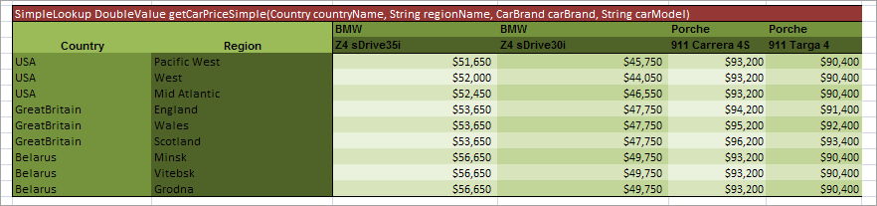

Figure 23: SimpleLookup table example

Ranges and Arrays in Simple Decision Tables
From the OpenL Tablets WebStudio 5.9.3, you can use Range and Array data types in SimpleRule tables and SimpleLookup tables. If a condition is represented as an Array or Range then the rule will be executed for any value from that array or range. As an example, in Figure 17, there is the same Car Price for all regions of Belarus and Great Britain, so, using an array, we can replace three rows for each of these countries by a single one as shown in Figure 18.
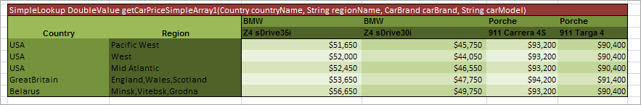
Figure 24: SimpleLookup table with an array
NOTE: If a string array element contains a comma, the element must be delimited with the backslash (\) separator forwarded by the comma as for Driver, Passenger, Side in the example below.
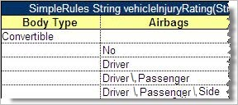
Figure 25: Comma within an array element in Simple Rule table
The example in Figure 20 shows how to use a Range in a SimpleRule table.
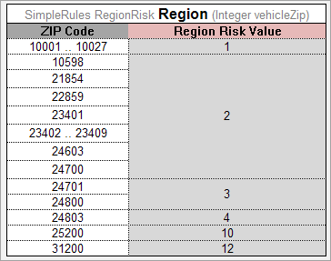
Figure 26: SimpleRules table with a Range
OpenL looks through the Condition column (ZIP Code), meets a range (not necessary the first one) and defines that all the data in the column are IntRange, where Integer is defined in the header (Integer vehicleZip).
We cannot use a range and an array in the same Condition column (OpenL issues an exception if so).

Decision Table Interpretation
Rules inside decision tables are processed one by one in the order they are placed in the table. A rule is executed only when all its conditions are true. If at least one condition returns false, all other conditions in the same row are ignored. Absence of a parameter in a condition cell is interpreted as a true value. Blank action and return value cells are ignored.

Local Parameters in Decision Table
When declaring Decision table users have to put next info in header: column type, code snippet, declarations of parameters, titles.
Recent experience shows that in 95% of cases users put very simple logic in code snippet such as just access to some field from input parameters. In this case the parameters declarations for the column are overhead and are useless.

Simplified declarations

Case#1
The following image represents situation when user should provide expression and simple equal operation for condition declaration.
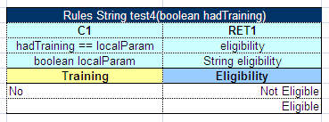
Figure 27: Decision Table where user should provide expression and simple equal operation for condition declaration
This code snippet can be simplified as shown on the next image.
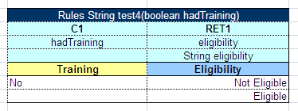

Figure 28: Simplified Decision Table

How it works?
(Just for your information. This passage can be interesting to understand internal OpenL Tablets logic.)
OpenL engine creates required parameter automatically when user omits parameter declaration with the following information:
- Parameter name will be "P1", where 1 is index of parameter
- Type of parameter will be the same as expression type (in our case it will be boolean)
In the next step OpenL will create appropriate condition evaluator.

Case#2
The following image represents situation when user can omit parameter name in declaration.
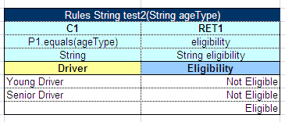

Figure 29: Decision Table where user can omit name in declaration
As mentioned in previous case OpenL engine generates parameter name and user can use it in expression but in this case user must provide local parameter type because expression type has different type than parameter.

Transposed Decision Tables
Sometimes decision tables look more convenient in transposed format where columns become rows and rows become columns. For example, a transposed version of the previously shown decision table resembles the following:
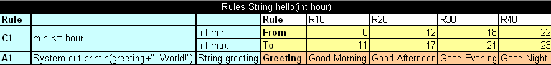

Figure 30: Transposed decision table
OpenL Tablets automatically detects transposed tables and is able to process them correctly.

Representing Arrays
For all tables that have properties of the enum[] type or fields of the array type, arrays can be defined as follows:
- horizontally
- vertically
- comma separated arrays
The first option is to arrange array values horizontally using multiple subcolumns. The following is an example of this approach:
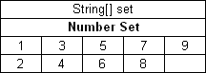

Figure 31: Arranging array values horizontally
In this example, the contents of the set variable for the first rule are [1,3,5,7,9] and for the second rule [2,4,6,8]. Values are read from left to right.
The second option is to present parameter values vertically as follows:
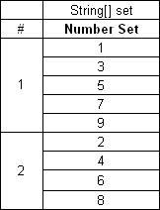

Figure 32: Arranging array values vertically
In the second case, the boundaries between rules are determined by the height of the leftmost cell. Therefore, an additional column must be added to the table to specify boundaries between arrays.
In both cases, empty cells are not added to the array.
The third option is to define an array separating values by a comma. If the value itself contains a comma, it must be escaped using back slash symbol “\” by putting it before the comma.
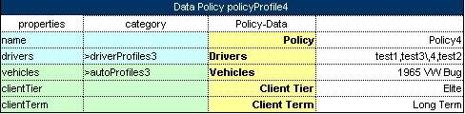

Figure 33: Array values separated by comma
In this example, the array consists of the following values:
- test 1
- test 3,4
- test 2
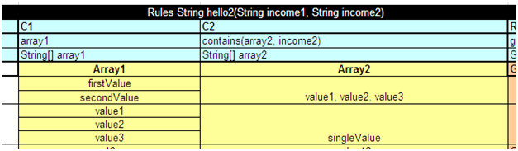

Figure 34: Array values separated by comma. The second example

In this example, the array consists of the following values:
- value1
- value2
- value3

Representing Date Values
To represent date values in table cells, the following format must be used:

'<month>/<date>/<year>
The value must always be preceded with an apostrophe. Excel treats these values as plain text and does not convert to any specific date format.
The following are valid date value examples:
'5/7/1981
'10/20/2002
OpenL Tablets also recognizes the native Excel date format.

Representing Boolean Values
OpenL Tablets supports the following formats of Boolean values:
- True, TRUE, Yes, YES
- False, FALSE, No, NO
OpenL Tablets also recognizes the Excel Boolean value, such as native Excel Boolean value TRUE or FALSE. For more information on Excel Boolean values, see Excel help.

Range types in OpenL
In OpenL there are the following Data types designed to work with ranges:
- IntRange
- DoubleRange
- CharRange
There are 3 ways to create IntRange:
- new IntRange(int min_number, int max_number) – it will cover all the numbers between min_number and max_number, including borders.
- new IntRange(Integer value) – it will cover only given value as the beginning and the end of the range.
- new IntRange(String rangeExpression). Borders will be parsed by formats of rangeExpression.
The same formats and restrictions are used in DoubleRange.

Supported range formats:
- “<min_number> – <max_number>” – borders will be included to range.
- “<min_number> .. <max_number>” – the same as 1.
- “<min_number> … <max_number>” – borders will not be included to range. Important: using of ".." and "..." requires spaces between numbers and dots.
- “<<max_number>” – the min_number will be Integer.MIN_VALUE and will be included to range. max_number will be out of the range.
- “<=<max_number>” – the min_number will be the same as in previous case, max_number will be also included to range.
- “><min_number>” – max_number in current case will be the Integer.MAX_VALUE and will be included to range. min_number will be out of range.
- “>=<min_number>” – max_number will be the same as in previous case. min_number will be included to range.
- “<min_number>+” – The same to “>= <min_number>”
- “[<min_number>; <max_number>”) – mathematic definition for ranges with using of square brackets for including borders and round brackets for not including.
- “[<min_number> .. <max_number>)” – brackets are used to include or not borders. See 9.
- “<min_number> and more” – the same to 7.
- “more than <min_number>” – the same to 6.
- “less than <max_number>” – the same to 4.
Also numbers can be enhanced with $ sign as prefix and K, M, B as postfix, e.g. $1K = 1000. For using negative values use ‘-’ (minus) sign before number (e.g. -<number>).

Using range types in Decision Tables
For example, we have the next Decision table. The column of type IntRange contains code statement of type short. So the cell may contain value of different types. When using IntRange, for user convenience it is possible to have code statement cell of following types:
- byte
- short
- int
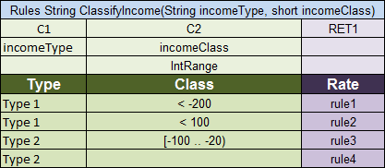

Figure 35: Decision table with IntRange

Be careful with using Integer.MAX_VALUE in Decision table. If there is a range with max_number equal to Integer.MAX_VALUE (e.g. [100; 2147483647]) it won`t be included to range. It is a known issue.
When using DoubleRange, for user convenience it is possible to have code statement cell of the following types:
- byte
- short
- int
- long
- float
- double

Using Calculations in Table Cells
OpenL Tablets can perform mathematical calculations involving method input parameters in table cells. For example, instead of returning a concrete number, a rule can return a result of a calculation involving one of the input parameters. Calculation result type must match the type of the cell. Text in cells containing calculations must start with an apostrophe followed by =. Excel treats such values as plain text. Alternatively, OpenL Tablets code can be enclosed by { }.
The following decision table demonstrates calculations in table cells:
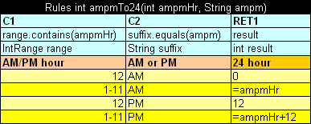

Figure 36: Decision table with calculations
The table transforms a 12 hour time format into a 24 hour time format. The column RET1 contains two cells that perform calculations with the input parameter ampmHr.
Calculations use regular Java syntax, similar to what is used in conditions and actions.
Note: Excel formulas are not supported by OpenL Tablets. They are used as precalculated values.

Datatype Table

Description
A Datatype table defines an OpenL Tablets data carrier. Using data types inside the OpenL Tablets rules is recommended, since using data types created in OpenL Tablets table from Java code is limited in the current implementation. For Java code, the preferable method is to use Java or Vocabulary type. For information on how this is done, see Data Table.
The following is an example of a Datatype table defining a custom data type called Person:
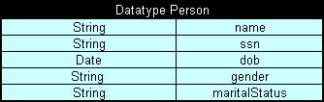

Figure 37: Datatype table
The first row is the header containing the keyword 'Datatype' followed by the name of the data type. Every row, beginning with the second one, represents one attribute of the data type. The first column contains attribute types; the second column contains corresponding attribute names.
There is an optional 3rd column, which defines default values for fields. The following example extends the data type Person with default values for some fields:
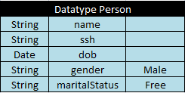

Figure 38: Datatype table with default values
Fields ‘gender’ and ‘male’ will have the given values for all newly created instances, if other values arn’t provided.

How OpenL handles Datatypes inside
Datatype tables are being processed after Properties Table — it is done to build a domain model that is used in rules.

Datatype header format:

[Datatype <typename>] or [Datatype <typename> extends <parentTypeName>] or [Datatype <typename> <aliastype>]

Datatype lifecycle
- Create a Datatype table in OpenL Tablets WebStudio.
- At runtime for each data type, java class is being generated (see Byte code generation at runtime).
- If the Generating a Static Wrapper was used and the goal ‘generate datatypes’ was called, the appropriate java files will be added to classpath (see Java files generation)

Inheritance in Data types
There is a possibility to inherit one data type from another in OpenL Tablets. New data type that inherits from another one will have access to all fields defined in the parent data type. If a child datatype contains fields that are defined in the parent data type you will get warnings or errors (if the field is declared with different types in the child and the parent data type).
Also constructor with all fields of the child datatype will contain all fields from the parent data type and toString, equals and hashCode methods will use all fields form the parent data type.

Byte code generation at runtime
At runtime, when OpenL engine instance is being built, for each datatype component java byte code is being generated in case there are no previously generated java files on classpath (see Java files generation) it represents simple java bean for this datatype. This byte code is being loaded to classloader so the object of type Class<?> can be accessible. Using this object through reflections new instances are being created and fields of datatypes are being initialized (see DatatypeOpenClass and DatatypeOpenField classes). Remember! If you have previously generated java files for your datatypes on classpath, they will be used at runtime. And it doesn't matter that you have made any changes in Excel. To apply these changes, remove java files and run Generating a Static Wrapper.

Java files generation
As generation of data types is performed at runtime and users can't access these classes in their code, so the "generate datatypes" goal was added to JavaWrapperAntTask. It adds the possibility of generating java files and putting them on the file system. So users can use these data types in their code.

Access datatype at runtime and after building OpenL wrapper
After parsing, each data type is put to compilation context, so it will be accessible for rules during binding. Also all data types are placed to IOpenClass of whole module and will be accessible from CompiledOpenClass#getTypes when OpenL wrapper is generated.
Each TableSyntaxNode that is of the xls.datatype type contains an object of data type as its member.

Working with Arrays from rules
There are two possibilities to work with Datatype arrays from rules:
- by numeric index, starting from 0
In this case by call drivers[5] you will get the 6th element of the Datatype array.
- by user defined index
The second case is a little more complicated. The first field of datatype is considered to be the user defined index. For example if we have a Datatype Driver with first String field name, we can create a Data Table, initializing two instances of Driver with names: John and David. Then in rules we can call the instance we need by drivers[“David”]. You can use all Java types (including primitives) and Datatypes for your indexes. When the first field of Datatype is of int type called id, to call the instance from array, wrap it with quotes: e.g. drivers[“7”], in this case you won`t get the 8th element in the array, but the Driver with id equals to 7.
- by conditional index
Another case is to use conditions that will consider which element (or elements) should be selected. For this purpose SELECT operators are used which specify conditions for selection. For details how to use SELECT operators refer to the Array Index Operators section
- by other array index operators and functions
To an array in your rules you can apply any index operator which is listed in the Array Index Operators section, or a function designed to work with arrays. The full list of OpenL Tablets array functions is provided in the Appendix B: Functions Used in OpenL Tablets.

Data Table
A data table contains relational data that can be referenced as follows:
- from other tables within OpenL Tablets
- from Java code through wrappers as Java arrays
- through OpenL Tablets run-time API as a field of the Rules class instance
Data tables can contain Java classes, OpenL Tablets data types, or types loaded in OpenL Tablets from other sources, for example, using the Vocabulary mechanism. For information on data types, see Datatype Table.
The following topics are included in this section:
- Using Simple Data Tables
- Using Advanced Data Tables
- Specifying Data for Aggregated Objects
- Ensuring Data Integrity

Using Simple Data Tables
The following is an example of a data table containing a simple array of numbers:
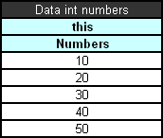

Figure 39: Simple data table
The first row is the header containing text in the following format:

Data <data table type> <data table name>
In simple data tables, the keyword 'this' must be used for the following types:
- all primitive Java types
- class java.lang.String
- class java.util.Date
- all Java classes with a public constructor with a single String parameter
In the example above, information in the data table can be accessed from Java code as shown in the following code example:
int[] num = tableWrapper.getNumbers();

for (int i = 0; i < num.length; i++) {
System.out.println(num[i]);
}
where tableWrapper is an instance of the wrapper class of the Excel file. For information on wrappers, see Wrappers.

Using Advanced Data Tables
Advanced data tables are used for storing information for complex constructions, such as Java beans and custom data types. For information on data types, see Datatype Table.
The first row of an advanced data table contains text in the following format:

Data <Java bean or data type> <data table name>
Each cell in the second row contains an attribute name of the data type or Java bean. Normally, the second row is hidden to business users.
The third row contains attribute display names. Each row starting with the fourth one contains values for specific data type instances.
The following diagram shows a datatype table and a corresponding data table with concrete values below it:
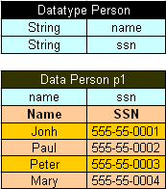

Figure 40: Datatype table and a corresponding data table
Data tables can use Java beans instead of data types. For example, instead of using a datatype table Person, a developer can use the following Java bean:
public class Person {

String name;
String ssn;

public String getName() {
return name;
}
public void setName(String name) {
this.name = name;
}

public String getSsn() {
return ssn;
}
public void setSsn(String ssn) {
this.ssn = ssn;
}

}
If a Java bean is used, to avoid compilation error, the package where the Java bean is located must be imported using a configuration table as described in Configuration Table.
In Java code, the data table p1 can be accessed as follows:
Person[] persArr = tableWrapper.getP1();

for (int i = 0; i < persArr.length; i++) {
System.out.println(persArr[i].getName() + ' ' + persArr[i].getSsn());
}
where tableWrapper is an instance of the Excel file wrapper. For information on wrappers, see Wrappers.

Specifying Data for Aggregated Objects
Data tables can be used to specify attributes of referenced objects. An object referenced by a data table is called an aggregated object. To specify an attribute of an aggregated object, the following format must be used in the row containing data table attribute names:

<name of reference to the aggregated object>.<object attribute>
To illustrate this approach, assume there are two Java classes ZipCode and Address defined:
public class ZipCode {

String zip1; // 5-digit part – mandatory
String zip2; // 4-digit part – optional

public String getZip1() {
return zip1;
}
public void setZip1(String zip1) {
this.zip1 = zip1;
}
public String getZip2() {
return zip2;
}
public void setZip2(String zip2) {
this.zip2 = zip2;
}
}

public class Address {
String street;
String city;
ZipCode zip;

public String getCity() {
return city;
}
public void setCity(String city) {
this.city = city;
}
public String getStreet() {
return street;
}
public void setStreet(String street) {
this.street = street;
}
public ZipCode getZip() {
return zip;
}
public void setZip(ZipCode zip) {
this.zip = zip;
}
}
As can be seen from the code, the Address class contains a reference to the ZipCode class. A data table can be created that specifies values for both classes at the same time, for example:
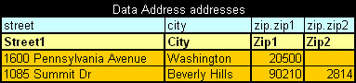

Figure 41: Specifying values for aggregated objects
In the preceding example, columns Zip1 and Zip2 contain values for class ZipCode referenced by class Address.
All Java classes referenced in a data table must be imported using a configuration table as described in Configuration Table.
Note: The reference path can be of any arbitrary depth, for example account.person.address.street.
In case a data table is to store information for an array of aggregated objects, OpenL Tablets allows us to specify attribute values for each element of an array. Then the following format should be used in the row of data table attribute names:

<name of reference to the aggregated object>[i].<object attribute>
where i - sequence number of an element, starts from 0.
The next example illustrates this approach:
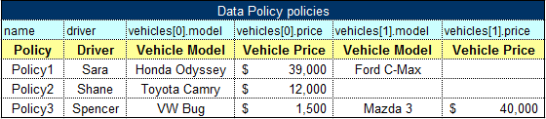

Figure 42: Specifying values for an array of aggregated objects
The first policy, Policy1, contains two vehicles: Honda Odyssey and Ford C-Max; the second policy, Policy2, – the only vehicle is Toyota Camry; the third policy, Policy3, contains two vehicles: VW Bug and Mazda 3.
Note: The approach is valid for simple cases with an array of simple Datatype values, and for complex cases with a nested array of an array, for example, policy.vehicles[0].coverages[2].limit.
Note: All mentioned formats of specifying data for aggregated objects are applicable in defining input values or expected result values in Test and Run Tables Types too.

Ensuring Data Integrity
If a data table contains values defined in another data table, it is important to specify this relationship. The relationship between two data tables is defined using foreign keys, a concept that is used in database management systems. Reference to another data table must be specified in an additional row below the row where attribute names are entered. The following format must be used:
> <referenced data table name> <column name of the referenced data table>
In the following example, the data table cities contains values from the table states. To ensure users enter correct values, a reference to the code column in the states table is defined.
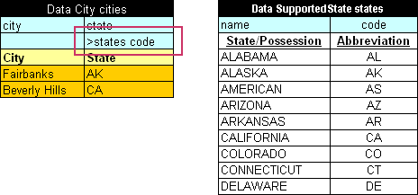

Figure 43: Defining a reference to another data table
In case user enters invalid state abbreviation in the table cities, OpenL Tablets reports an error.
The target column does not have to be specified if it is the first column in the referenced data table. For example, if a reference was made to the column name in the table states, the following simplified reference could be used:

>states
In case a data table contains values which are defined as part of another data table, the following format can be used:
> <referenced data table name>.<attribute name> <column name>
The difference with the previous format is that you additionally specify an attribute name of the referenced data table whose corresponding values are included in the other data table.
If <column name> is omitted then, by default, the reference is constructed using the first column of the referenced data table.
In the following diagram, the data table claims contains values defined in the table policies and related to the vehicle attribute. A reference to the column name of the table policies is omitted as this is the first column in the table.
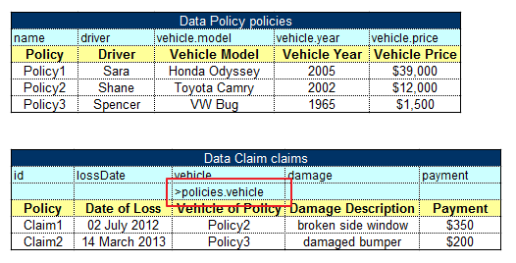

Figure 44: Defining a reference to another data table
Note: To ensure users enter correct values, cell data validation lists can be used in Excel limiting the range of values users can type in.
Note: The syntax of data integration is applicable in defining input values or expected result values in Test and Run Tables Types too.
Note: The attribute path can be of any arbitrary depth, for example >policies.coverage.limit.

Test Table
A test table is used to perform unit tests on executable tables, such as decision tables, method tables, spreadsheet tables etc. It calls a particular table, provides test input values, and checks whether the returned value matches the expected value. Test tables are mostly used for testing decision tables.
Note: Test tables can be used to execute any Java method but in that case a method table must be used as a proxy.
For example, in the following diagram, the table on the left is a decision table but the table on the right is a unit test table that tests data of the decision table:
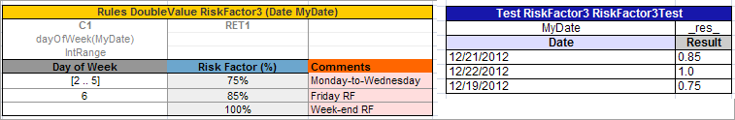

Figure 45: Decision table and its unit test table
A test table has the following structure:
- The first row is the table header, which has the following format:

Test <rule name> <test table name>
'Test' is a keyword that identifies a test table. The second parameter is the name of the decision table or any other Java method to be tested. The third parameter is the name of the test table, which is also the name of the method by which the test table can be executed from Java code.
- The second row provides a separate cell for each input parameter of the decision table followed by column _res_, which typically contains the expected test result values.
- The third row contains display values intended for business users.
- Starting with the fourth row, each row is an individual test run.
How to specify values of input parameters and expected test results which have complex constructions, refer to "Specifying Data for Aggregated Objects" and "Ensuring Data Integrity".
When a test table is called, the OpenL Tablets engine calls the specified rule for every row in the test table and passes the corresponding input parameters to it.
Application run-time context values are defined in the run-time environment. Test tables for overloaded tables must provide values for the run-time context significant for the tested table. Run-time context values are accessed in the test table through the _context_ prefix. An example of a test table with the context value Lob follows:
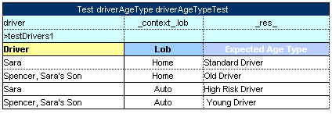

Figure 46: An example of a test table with a context value

You can also use the _description_ column to enter any useful information.
User can use the _error_ column of Test table to test algorithm where error function is used. OpenL engine compares error message and value of _error_ column to decide is test passed or not.
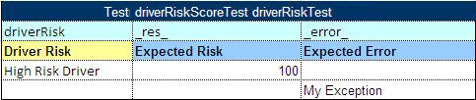

Figure 47: An example of a test table with an expected error column
Test results can be accessed through the test table API. For example, the following code fragment executes all test runs in a test table called insuranceTest and displays the number of failed test runs:
TableWrapper tableWrapper = new TableWrapper();

TestResult tr = tableWrapper.insuranceTestTestAll();

System.out.println("Number of failed test runs: "+tr.getNumberOfFailures());
If OpenL Tablets projects are accessed and modified through OpenL Tablets WebStudio, the user interface provides more advanced and convenient utilities for running tests and viewing test results. For information on using OpenL Tablets WebStudio, see OpenL Tablets WebStudio User's Guide.

Context Variables Available in Test Tables
The following context variables are available in OpenL Tablets Test Tables.
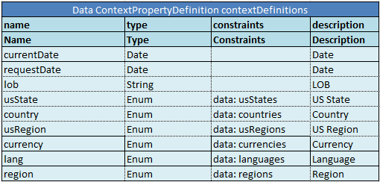

Testing Spreadsheet with Custom Spreadsheet Result Turned On
If the Custom Spreadsheet result feature is activated, it is possible to test cells of a Spreadsheet table in the following way. Let’s use the Spreadsheet table shown in the Figure below.
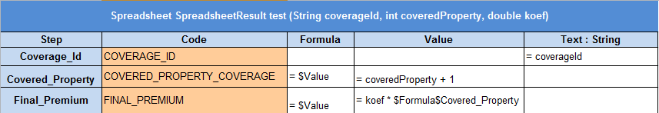

Figure 48: A sample Spreadsheet table
For testing purposes, standard Test component is used. You can access cells of the Spreadsheet by using the _res_.$<ColumnName>$<RowName> expression.
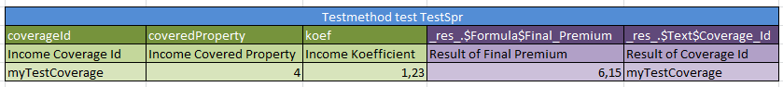

Figure 49: Test for the sample Spreadsheet table
Columns marked with green color determine the income values, and the columns marked with lilac determine the expected values for some number of cells. It is possible to test as much cells as you need.
As a result of running this test in the WebStudio you will see the next output table.
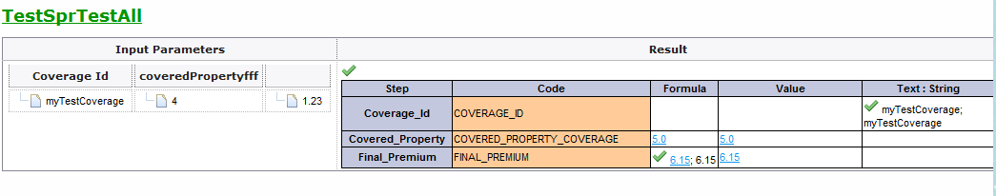
Figure 50: The sample Spreadsheet test results

Run Table
A run table calls a particular decision table or method table multiple times and provides input values for each individual call. Therefore, run tables are similar to test tables, except they do not perform a check of values returned by the called method.
Note: Run tables can be used to execute any Java method.
The following is an example of a run method table:
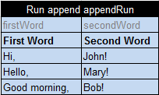

Figure 51: Run table
This example assumes there is a method append defined with two input parameters, firstWord and secondWord. The run method table calls this method three times with three different sets of input values.
A run method table has the following structure:
- The first row is a table header, which has the following format:

Run <method to call> <run>
- The second row contains cells with method input parameter names.
- The third row contains display values intended for business users.
- Starting with the fourth row, each row is a set of input parameters to be passed to the called method.
How to specify values of input parameters which have complex constructions, refer to "Specifying Data for Aggregated Objects" and "Ensuring Data Integrity".

Method Table
A method table is a Java method described within a table. The following is an example of a method table:
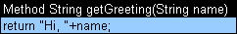

Figure 52: Method table
The first row is a table header, which has the following format:

<keyword> <return type> <method name and parameters>
where <keyword> is either 'Method' or 'Code'.
The second row, and the following rows, is the actual code to be executed. It can reference parameters passed to the method and all Java objects and tables visible to the OpenL Tablets engine.
Method in the preceding example table can be called from Java code as follows:
ApprovalRulesWrapper tableWrapper = new ApprovalRulesWrapper();

System.out.println(tableWrapper.getGreeting("John"));

Configuration Table
OpenL Tablets allows externalizing business logic into Excel files. However, these files can still use objects and methods defined in the Java environment. To enable use of Java objects and methods in Excel tables, the file must have a configuration table. A configuration table provides information to the OpenL Tablets engine about available Java packages. Another purpose of a configuration file is to point to other Excel files that can be referenced in tables.
A configuration table is identified by the keyword 'Environment' in the first row. No additional parameters are required. Starting with the second row, a configuration table must have two columns. The first column contains commands and the second column contains input strings for commands.
The following commands are supported in configuration tables:
Configuration table commands
Command | Description
import | Imports the specified Java package so that its objects and methods can be used in tables.
include | Includes another Excel file so that its tables and data can be referenced in tables of the current file.
language | Language import functionality.
extension | External set of rules for expanding OpenL Tablets capabilities. After adding, external rules are complied with OpenL Tablets rules and work jointly.
vocabulary | Ability to use user created dynamic classes in OpenL Tablets.
dependency | Adds the dependency module by its name. All data from this module will be accessible in current one.
The following is an example of a configuration table:
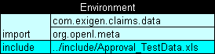

Figure 53: Configuration table

Properties Table

Description
A properties table is used to define the module and category level properties inherited by tables. The properties table has the following structure:
Properties table elements
Element | Description
Properties | Reserved word that defines the type of the table. It can be followed by a Java identifier. In this case, the properties table value becomes accessible in rules as a field of such name and of the TableProperties type.
scope | Identifies levels on which the property inheritance is defined. Available values are as follows:
  Scope level | Description
  Module | Identifies properties defined for the whole module and inherited by all tables in it. There can be only one table with the Module scope in one module.  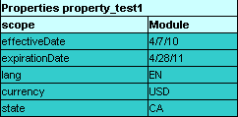  Figure 54: A properties table with the Module level scope
  Category | Identifies properties applied to all tables where the category name equals the name specified in the category element.  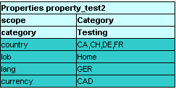  Figure 55: A properties table with the Category level scope
category | Defines the category if the scope element is set to Category. If no value is specified, the category name is retrieved from the sheet name.
Module | Identifies that properties can be overridden and inherited on the Module level.

Spreadsheet Table
A spreadsheet table, in OpenL Tablets, is an analogue of the Excel table with rows, columns, formulas, and calculations as contents. Spreadsheets can also call decision tables or other executable tables to make decisions on values, and based on those, make calculations.
The format of the spreadsheet table header is as follows:
Spreadsheet SpreadsheetResult nameOfTableOrMethod(ARGUMENTS)
or
Spreadsheet <datatype> nameOfTableOrMethod(ARGUMENTS)
The following table describes the spreadsheet table header syntax:
Spreadsheet table header syntax
Element | Description
Spreadsheet | Reserved word that defines the type of the table.
SpreadsheetResult | Type of the return value. SpreadsheetResult returns the calculated content of the whole table.
<datatype> | Type of the returned value. If only a single value is required, its type must be defined here as a return datatype and calculated in the row or column named RETURN
nameOfTableOrMethod | Java valid name of the table as for any executable table.
ARGUMENTS | Input arguments as for any executable table.
The first column and row of a spreadsheet table make the table column and row names. Values in other cells are the table values. An example follows:
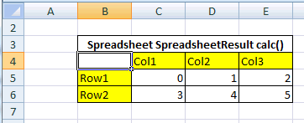

Figure 56: Spreadsheet table organization
A spreadsheet table can contain simple values, such as a string, numeric, range value, or an advanced value referencing another cell value. The following table describes how another cell value can be referenced in a spreadsheet table:
Referencing another cell
Notation | Reference | Description
{$columnName} | By column name | Used to refer to the value of another column in the same row.
{$rowName} | By row name | Used to refer to the value of another row in the same column.
{$columnName$rowName} | Full reference | Used to refer to the value of another row and column.

Parsing of Spreadsheet Table
OpenL Tablets processes Spreadsheet tables in two different ways depending on the return type:
- Spreadsheet returns SpreadsheetResult datatype.
- Spreadsheet returns any other datatype different from the first point.
In the first case you will get the SpreadsheetResult type that is an analog of result matrix. All the calculated cells of the Spreadsheet table will be accessible through this result. The following example shows Spreadsheet table of this type.
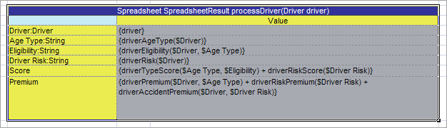
Figure 57: Spreadsheet table returns SpreadsheetResult datatype
In the second case the returned result is a datatype as in all other rule tables (you don’t have ‘SpreadsheetResult’ in the rule table header). The cell with the RETURN key word for a row will be returned. OpenL will calculate the cells that are needed just for that result calculation. In the following example the ‘License_Points’ cell will not be included in the ‘Tier Factor’ calculation, it should simply be skipped.
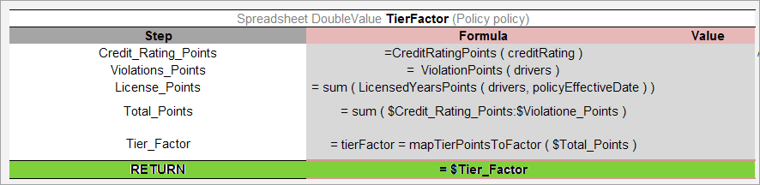
Figure 58: Spreadsheet table returns a single value

Custom Spreadsheet Result
From OpenL Tablets 5.9.0 it is possible to improve the usage of spreadsheet tables that return the SpreadsheetResult type. Now there is a possibility to have a separate type for each Spreadsheet table at OpenL runtime.
This feature gives you the following advantages:
- A possibility to explicitly define the type of the returned value. In other words, you don’t need to indicate a datatype when accessing the cell.
- Simplification of accessing Spreadsheet cells.
- Test any Spreadsheet cell (see Testing Custom Spreadsheet result for details).
By default, the feature is turned off. Please refer to the System Settings section in OpenL Tablets WebStudio User Guide for information on how to turn it on.
To understand how it works, let's have a look at the next spreadsheet.

Figure 59: An example of the Spreadsheet
The return type is SpreadsheetResult. Now it is possible to access any calculated cell, for example, as it is shown in the figure below:
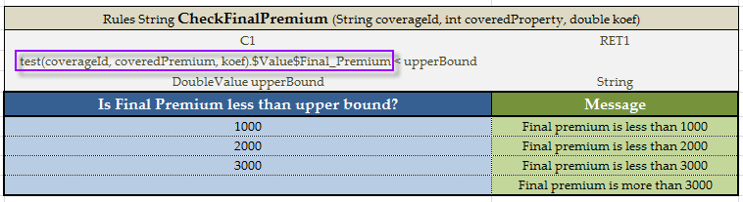

Figure 60: Calling Spreadsheet cell
In this example we are accessing the Spreadsheet table cell from the returned SpreadsheetResult.
You can also access the spreadsheet cell using the getFieldValue(String cellName) function.
Note: There are some limitations:
- If the cell name in columns or rows contains not allowed symbols (space, percentage, etc – see not allowed symbols for Java methods), it is impossible to access the cell.
- Currently it is impossible to use this feature when you are planning to use Business Dimension Properties. But you still can use it in all other tables.

Testing Spreadsheet with Custom Spreadsheet Result Turned On
If the Custom Spreadsheet result feature is activated, it is possible to test cells of a Spreadsheet table in the following way. Let’s use the Spreadsheet table shown in the Figure below.

Figure 61: A sample Spreadsheet table
For testing purposes, standard Test component is used. You can access cells of the Spreadsheet by using the _res_.$<ColumnName>$<RowName> expression.

Figure 62: Test for the sample Spreadsheet table
Columns marked with green color determine the income values, and the columns marked with lilac determine the expected values for some number of cells. It is possible to test as much cells as you need.
As a result of running this test in the WebStudio you will see the next output table.
Figure 63: The sample Spreadsheet test results

Using Ranges in Spreadsheet Table
When you work with a range in a spreadsheet table, you can use the following syntax: ($FirstValue:$LastValue) to specify your range. In the figure below, there is an example of using range this way (the TotalAmount column).
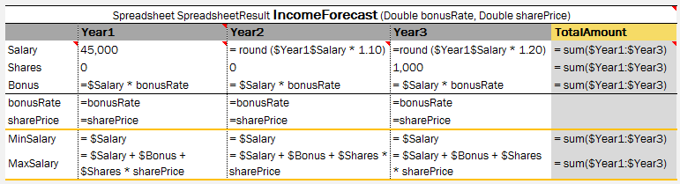

Figure 64: Using ranges of Spreadsheet table in functions
NOTE: In expression like ‘min/max($FirstValue:$LastValue)’, there should be no space before and after the colon (:) operator.

Column Match Table
A column match table has an attached algorithm. The algorithm denotes the table content and how the return value is calculated. Usually this type of table is referred to as a Decision Tree.
The format of the column match table header is as follows:
ColumnMatch <ALGORITHM> ReturnType nameOfTableOrMethod(ARGUMENTS)
The following table describes the spreadsheet table header syntax:
Column match table header syntax
Element | Description
ColumnMatch | Reserved word that defines the type of the table.
ALGORITHM | Name of the algorithm. This value is optional.
ReturnType | Type of the return value.
nameOfTableOrMethod | Java valid name of the table or method as for any executable table, exposing this table in an OpenL Tablets wrapper.
ARGUMENTS | Input arguments as for any executable table.
The following predefined algorithms are available:
Predefined algorithms
Element | Reference
MATCH | MATCH Algorithm
SCORE | SCORE Algorithm
WEIGHTED | WEIGHTED Algorithm
Each algorithm has the following mandatory columns:
Algorithm mandatory columns
Column | Description
Names | Names refer to the table or method arguments and bind an argument to a particular row. The same argument can be referred in multiple rows.  Arguments are referenced by their short names. For example, if an argument in a table is a Java Bean with the some property, it is enough to specify some in the names column.
Operations | The operations column defines how to match or check arguments to values in a table. The following operations are available:  The min and max operations work with numeric and date types only.  The min and max operations can be replaced with the match operation and ranges. This approach adds more flexibility because it enables the checking of all cases within one row.
  Operation | Checks for | Description
  match | equality or belonging to a range | The argument value must be equal to or within a range of check values.
  min | minimally required value | The argument must not be less than the check value.
  max | maximally allowed value | The argument must not be greater than the check value.
Values | The values column typically has multiple sub columns containing table values.

MATCH Algorithm
The MATCH algorithm enables the user in mapping a set of conditions to a single return value.
Besides the mandatory columns, which are names, operations, and values, the MATCH table expects that the first data row contains Return Values, one of which is returned as a result of the ColumnMatch table execution.
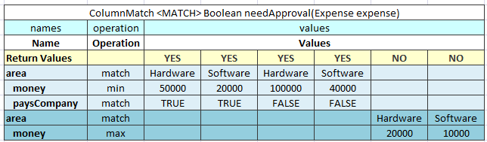

Figure 65: An example of the MATCH algorithm table
The MATCH algorithm works up to down and left to right. It takes an argument from the upper row and matches it against check values from left to right. If they match, the algorithm returns the corresponding return value, which is the one in the same column as the check value. If values do not match, the algorithm switches to the next row. If no match is found in the whole table, the null object is returned.
If the return type is primitive, such as int, double, or Boolean, a run-time exception is thrown.
The MATCH algorithm supports AND conditions. In this case, it checks whether all arguments from a group match the corresponding check values, and checks values in the same value sub column each time. The AND group of arguments is created by indenting two or more arguments. The name of the first argument in a group must be left unintended.

SCORE Algorithm
The SCORE algorithm calculates the sum of weighted ratings or scores for all matched cases. The SCORE algorithm has the following mandatory columns:
- names
- operations
- weight
- values
The algorithm expects that the first row contains Score, which is a list of scores or ratings added to the result sum if an argument matches the check value in the corresponding sub column.
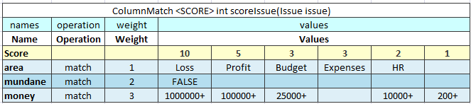

Figure 66: An example of the SCORE algorithm table
The SCORE algorithm works up to down and left to right. It takes the argument value in the first row and checks it against values from left to right until a match is found. When a match is found, the algorithm takes the score value in the corresponding sub column and multiples it by the weight of that row. The product is added to the result sum. After that, the next row is checked., The rest of the check values on the same row are ignored after the first match. The 0 value is returned if no match is found.
The following limitations apply:
- Only one score can be defined for each row.
- AND groups are not supported.
- Any amount of rows can refer to the same argument.
- The SCORE algorithm return type is always integer.

WEIGHTED Algorithm
The WEIGHTED algorithm combines the SCORE and simple MATCH algorithms. The result of the SCORE algorithm is passed to the MATCH algorithm as an input value. The MATCH algorithm result is returned as the WEIGHTED algorithm result.
The WEIGHTED algorithm requires the same columns as the SCORE algorithm. Yet it expects that first three rows are Return Values, Total Score, and Score. Return Values and Total Score represent the MATCH algorithm, and the Score row is the beginning of the SCORE part.
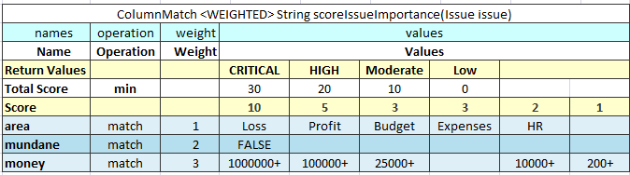

Figure 67: An example of the WEIGHTED algorithm table
The WEIGHTED algorithm requires the use of an extra Method table that joins the SCORE and MATCH algorithm. Testing the SCORE part can become difficult in this case. Splitting the WEIGHTED table into separate SCORE and MATCH algorithm tables is recommended.

TBasic Table
A TBasic table is used for code development in more convenient and structured way rather than using Java or Business User Language (BUL). It has several clearly defined structural components. Using Excel cells, fonts, and named code column segments provides clearer definition of complex algorithms.
In a definite UI, it can be used as a workflow component.
The format of the TBasic table header is as follows:
TBasic <ReturnType> <TechnicalName> (ARGUMENTS)
The following table describes the TBasic table header syntax:
Tbasic table header syntax
Element | Description
TBasic | Reserved word that defines the type of the table.
ReturnType | Type of the return value.
TechnicalName | Algorithm name.
ARGUMENTS | Input arguments as for any executable table.
The following table explains the recommended parts of the structured algorithm:
Algorithm parts
Element | Description
Algorithm precondition or preprocessing | Executed when the component starts execution.
Algorithm steps | Represents the main logic of the component.
Postprocess | Identifies a part executed when the algorithm part is executed.
User functions and subroutines | Contains user functions definition and subroutines.

Table Part
A Table Part functionality enables the user to split a large table into smaller parts (partial tables). Physically in the Excel workbook the table is represented as several Table Parts but logically it’s processed as one rules table.
This functionality is suitable for cases when the user is dealing with .xls file format and a rules table exists with more than 256 columns or 65,536 rows. To create such rule table, the user can decompose the table into several parts and place each part on a separate worksheet.
Splitting can be vertical or horizontal. In vertical case, the first N1 rows of an original rule table are placed in the 1st Table Part, the next N2 rows - in the 2nd and so on. In horizontal case, the first N1 columns of the rule table are placed in the 1st Table Part, the next N2 columns – in the 2nd and so on. The header of the original rule table and its properties definition should be copied in each Table Part in case of horizontal splitting. Merging of Table Parts into the rule table is processed as depicted on Figure 68 and Figure 69.
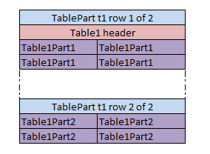
Figure 68: Vertical merging of Table Parts
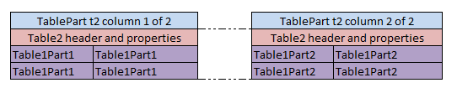
Figure 69: Horizontal merging of Table Parts
All Table Parts should be located within the one Excel file.
Splitting can be applied for any tables of Decision, Data, Test and Run types.
The format of the TablePart header is as follows:
TablePart <table id> <split type> {M} of {N}
The following table describes the TablePart header syntax:
Table Part header syntax
Element | Description
TablePart | Reserved word that defines the type of the table.
<table id> | A unique name of the rules table. Can be the same as the rules table name if the rules table is not overloaded by properties.
<split type> | Type of splitting. Set to “row” for vertical splitting; “column” – for horizontal splitting.
{M} | Sequential number of the Table Part: 1, 2, and so on.
{N} | Total number of Table Parts of the rule table.
Examples below illustrate vertical and horizontal splitting of decision rule RiskOfWorkWithCorporate:
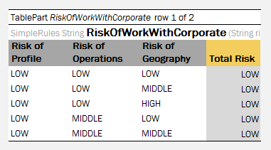
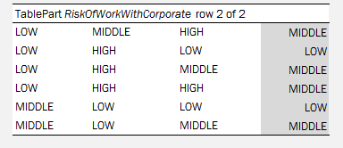
Figure 70: Table Parts example. Vertical splitting
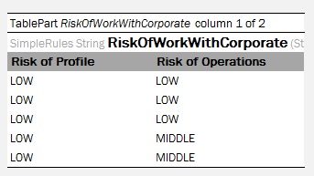
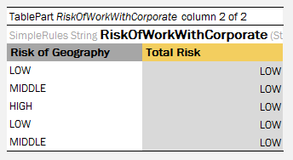
Figure 71: Table Parts example. Horizontal splitting

Chapter 3: OpenL Tablets Functions and Supported Data Types
This section is intended for OpenL Tablets users to help them better understand how their business rules are processed in the OpenL Tablets system.
To implement your business rules logic you need to instruct OpenL Tablets what you want to do. For this you will create one or several rule tablets which will contain description of your rules logic.
Usually rules operate with some data (from your domain) to perform certain actions or return some results. The actions are performed using functions which, in turn, support particular Data Types.
This section describes Data Types and the functions that you will use to manage your business rules in the system. Basic principles of the use of Arrays are provided as well.
The section includes the following topics:
- Arrays in OpenL Tablets
- Working with Data Types
- Working with Functions

Arrays in OpenL Tablets
An array is a collection of values of the same type. Separate values in this case are called array elements. An array element is a value of any Data Type available in the system: IntValue, Double, Boolean, String, etc. (For more information on OpenL Tablets Data Types refer to the Working with Data Types section.) The square brackets in the name of Data Type indicate that you are dealing with an array of values in your rule. For example, you can use the String[] expression to represent an array of text elements of the ‘String’ Data Type, such as US state names – CA, NJ, VA, etc. In your rules you will use arrays for different purposes such as calculating statistics, representing multiple rates, and so on.

Array Index Operators
Array index operators are operators which facilitate working with arrays in rules. Index operators are specified in square brackets of the array and apply particular actions to array elements.
For better understanding of index operators usage, let us provide a detailed description of them along with examples. OpenL Tablets supports the following index operators:
- SELECT Operators
There are cases when it’s required to use conditions that will consider which element (or elements) of the array should be selected. For example, if we have a Datatype Driver with fields; name (of type String), age (of type Integer), etc and we need to select all drivers with name John with age under 20. Then we can use the SELECT operator realizing conditional index like arrayOfDrivers[select all having name == “John” and age < 20].
There are two different types of SELECT operators:
- Index operator that returns the first element satisfying the condition.
Returns the first matching element or null if there is no such element.
Syntax: array[!@ <condition>] or array[select first having <condition>]
Example: arrayOfDrivers[!@ name == “John” and age < 20]
- Index operator that returns all elements satisfying the condition.
Returns the array of matching elements or empty array if there are no such elements.
Syntax: array[@ <condition>] or array [select all having <condition>]
Example: arrayOfDrivers[@ numAccidents > 3]
- ORDER BY Operators
These operators are intended to sort elements of the array. For example, we have a Datatype Claim with fields; lossDate (of type Date), paymentAmount (of type Double), etc and we need to sort all claims by loss date starting with the earliest one. Then we should use ORDER BY operator like claims[order by lossDate].
There are two ways of sorting:
- sort elements with increasing ordering.
Syntax: array[^@ <expression>] or array[order by <expression>] or array[order increasing by <expression>]
Example: claims[^@ lossDate]
- sort elements with decreasing ordering.
Syntax: array[v@ <expression>] or array[order decreasing by <expression>]
Example: claims[v@ paymentAmount]
The operator returns the array with ordered elements. It saves element order in case of equal elements. <expression>, by which ordering performs, must have comparable type (like Date, String, Number).
- SPLIT BY Operator
If you need to split array elements into groups by some criteria, just use SPLIT BY operator which returns collection of arrays with elements in each array of the same criteria. For example, codes = {"5000", "2002", "3300", "2113"}; codes[split by substring(0,1)] will produce 3 collections {"5000"}, {"2002", "2113"} and {"3300"} which unite codes with equal first number.
Syntax: array[~@ <expression>] or array[split by <expression>]
Example: orders[~@ orderType]
where orders of Order[] Datatype, custom Datatype Order has a field orderType for defining a category of the Order. The operator from the example produces Order[][] split by different categories.
So SPLIT BY operator returns 2-dimentional array containing arrays of elements split by equal value of <expression>. Saves relative element order.
- TRANSFORM TO Operators
This operator gives us an opportunity to turn source array elements into another transformed array in a quick way. Let us assume that we have the collection of claims and we’d like to return claim ID and loss date information for each claim (in form of array of strings). Then we could use TRANSFORM TO operator like claims[transform to id + " - " + dateToString(lossDate, "dd.MM.YY")].
There are two types of transforming:
- Index operator that transforms elements and returns the whole transformed array.
Syntax: array[*@ <expression>] or array[transform to <expression>]
Example: drivers[*@ name]
- Index operator that transforms elements and returns just unique elements of the transformed array.
Syntax: array[*!@ <expression>] or array[transform unique to <expression>]
Example: drivers[*!@ vehicle]
The example above produces collection of vehicles , and in this collection each vehicle is listed only once (without identical vehicles).
The operator return array of the <expression> Type. It saves the order of the elements.
Any field, method of the collection element, any OpenL Tablets function can be used in <condition> / <expression>, like in examples: claims[order by lossDate], where lossDate is a field of the array element Claim; arrayOfCarModels[@ contains("Toyota")], where contains is a method of String element of the array arrayOfCarModels.

Advanced usage:
Let us consider a case when the name of an array element needs to be referred explicitly in condition/expression. For example, the policy has a collection of drivers (of Driver[] Datatype) and we want to select all policy drivers with age less than 19, except for the primary driver. The following syntax with explicit definition of the collection element Driver d allows us to do that:
policy.drivers[(Driver d) @ d != policy.primaryDriver && d.age < 19]
The expression could be written without type definition in case when the element type is known:
policy.drivers[(d) @ d != policy.primaryDriver && d.age < 19]

Note: For experienced users. There is a possibility to apply array index operators for Lists. Usually in this case it’s necessary to use named element to define type of the list's components like List claims = policy.getClaims(); claims[(Claim claim) order by claim.date] or List claims = policy.getClaims(); claims[(Claim claim) ^@ date].

Rules Applied to Array
Regarding arrays, OpenL Tablets provides a feature that allows you to apply a rule (that is intended for working with one value) to an array of values. The following example demonstrates this feature in very simple way.
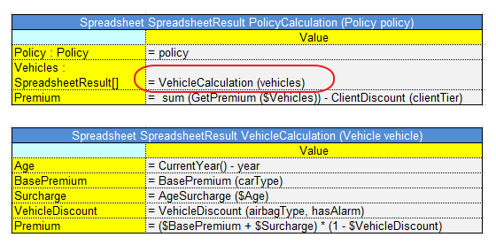
Figure 72: Applying a rule to an array of values
The rule VehicleCalculation is designed for working with one vehicle as input parameter and returns one Spreadsheet as a result. In the example this rule is applied for an array of vehicles which means that it is executed for each vehicle and returns an array of Spreadsheet results.

Working with Data Types
All data types used in OpenL Tables can be divided into two groups: Predefined Data Types and Custom Data Types. Predefined Data Types are those existing in OpenL Tablets that you can use but cannot modify. Custom Data Types can be created in OpenL Tablets WebStudio as described in the Datatype Table section.
This section describes Predefined Data Types that include the following ones:
- Simple Data Types
- Value Data Types
- Range Data Types

Simple Data Types
The following table lists Simple Data Types that you will use in your business rules in OpenL Tablets.
Data Type | Description | Examples | Usage in OpenL Tablets | Notes
Integer | It is used to work with whole numbers (without fraction points) | 8; 45; 12; 356; 2011 | It is common for representing a variety of numbers such as driver’s age, a year, a number of points, mileage, etc. | Not exceeding 2,147,483,647
Double | It is used for operations with fractional numbers. Can hold very large (or very small) numbers. | 8.4; 10.5; 12.8; 12,000.00; 44.416666666666664 | It is commonly used for calculating balances or discount values, for representing exchange rates, a monthly income, etc.
BigInteger | It is used to operate with whole numbers that exceed the values allowed by the Integer  data type (The maximum Integer value is 2147483647). | 7,832,991,657,779;20,000,000,013 | This Data Type is only used for operations on very big values – over two billion, for example, dollar deposit in Bulgarian Leva equivalent.
BigDecimal | It enables to represent decimal numbers with very high precision. Can be used to work with decimal values that have more than 16 significant digits especially when precise rounding is required. | 0,6666666666666666667 | This Data Type is often used for currency calculations or in financial reports that require exact mathematical calculations, for example a year bank deposit premium calculation.
String | The String Data Type is used to represent text rather than numbers. String values are comprised of a set of characters that can also contain spaces and numbers. For example, the word "Chrysler" and the phrase "The Chrysler factory warranty is valid for 3 years" are both Strings. | John Smith, London, Alaska, BMW; Driver is too young. | This Data Type is used for representing cities, states, people names, car models, genders, marital statuses, as well as messages such as warnings, reasons, notes, diagnosis, etc.
Boolean | This Data Type has only two possible values: true and false. For example, if a Driver is trained (condition is true) then his or her insurance premium coefficient is 1.5; if the Driver is not trained (the condition is false) then the coefficient is 0.25. | true; yes; y; false; no; n | Is used to handle conditions in OpenL Tablets. | The synonym for ‘true’ is ‘yes’, ‘y’; for ‘false’ – ‘no’, ‘n’
Byte, Character, Short, Long, Date, and Float data types are rarely used in OpenL Tablets, so we will only provide here the ranges of the values. For more information about them please refer to appropriate Java portal pages.
Data Type | Min | Max
Byte | -128 | 127
Character | 0 | 65535
Short | -32768 | 32767
Long | -9223372036854775808 | 9223372036854775807
Float | 1.5*10⁻⁴⁵ | 3.4810³⁸

Value Data Types
In OpenL Tablets Value Data Types are completely the same as Simple Data Types except for an explanation — a clickable field that you can see in the test results table in OpenL Tablets WebStudio as shown in the illustration below. These data types provide detailed information on results of the rules testing and are useful for working with calculated values to have better debugging capabilities. By clicking the linked value you can view the source table for that value and get information on how the value was calculated.
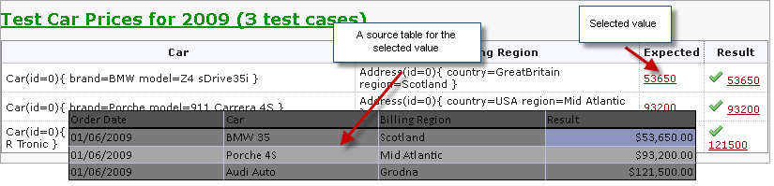
Figure 73: Usage of Value Data Type
OpenL Tablets supports the following Value Data types: ByteValue, ShortValue, IntValue, LongValue, FloatValue, DoubleValue, BigIntegerValue, BigDecimalValue.

OpenL Tablets Data Types
This section describes OpenL Tablets Data Types that are specific for OpenL Tablets and can be unavailable in other business rules systems.

Range Data Types
You will want to use the Range Data Types in cases when your business rule should be applied to a group of values. For example, a driver’s insurance premium coefficient is usually the same for all drivers from within a particular age group. So you can define a range of ages, and create one rule for all drivers from within that range. All that you need to inform OpenL Tablets that the rule shall be applied to a group of drivers is to declare driver’s age as the Range Data Type.
There are two Range Data Types in OpenL Tablets:
IntRange – The IntRange Data Type is intended for processing whole numbers within an interval. For example, vehicle or driver age for calculation of insurance compensations, years of service when calculating the annual bonus and so on.
DoubleRange – The DoubleRange Data Type is used for operations on fractional numbers within a certain interval. For instance, annual percentage rate in banks depends on amount of deposit which is expressed as intervals: 500 – 9,999.99; 10,000 – 24,999.99 etc.
The illustration below provides very simple example of how to use Range Data Type. The value of discount percentage depends on the number of orders and is the same for 4 to 5 orders and 7 to 8 orders. We have defined amount of cars per order as IntRange Data Type. For number of orders from, for example, 6 to 8 the rule for calculating the discount percentage is the same: The discount percentage is 10.00% for BMW, 4.00% for Porsche, and 6.00% for Audi.
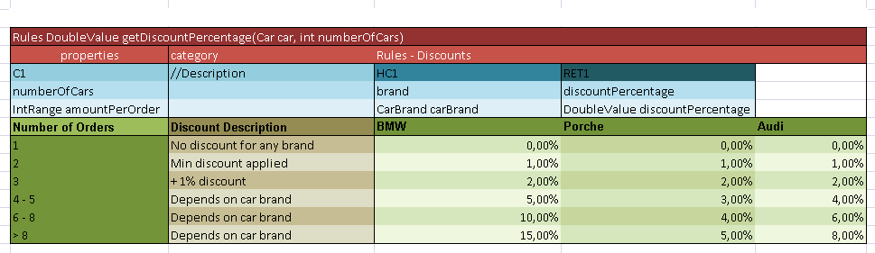
Figure 74: Usage of the Range Data Type

Alias Data Types
An alias Data type allows you to define possible values for a particular data type. In the example below, the MaritalStatus Data type can only be ‘Married’ or ‘Single’.
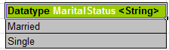
Figure 75: Usage of the Alias Data Type

Working with Functions
In the previous section we discussed Data Types that OpenL Tablets uses for representing your data in the system. To implement your business logic in the rules, you will use functions. For example, the Sum function is used to calculate a sum of values, the Min/Max functions enable you to find the minimum or maximum values in a set of values, etc. This section describes OpenL Tablets functions and provides some simple examples of their usage. All the functions can be divided into the following groups:
- Math functions
- Array processing functions
- Date functions
- String functions
- Errors handling functions

Understanding OpenL Function Syntax
This section provides a brief description of how the functions work in OpenL Tablets. Any function is represented by the function name (or identifier) such as sum, sort, median; the function parameter(s); and a value (or values) that the function returns. For example, in the max(value1, value2) expression, ‘max’ is the rule/function name, (value1, value2) – are the function parameters, i. e. values that take part in the action. If you determine value1 and value2 as 50 and 41, the given function will look as follows: max(50, 41) and returns ‘50’ in result as the biggest number in the couple. If we want an action to be performed in a rule, we should use the corresponding function in the rules table. For example, to calculate the best result for a gamer in the example below, we shall use the max function and write max(score1, score2, score3) in the C1 column. This expression instructs OpenL Tablets to select the maximum value in the set. The contains function can be used then to determine the gamer level.
Subsequent sections provide description for a few often used OpenL Tablets functions. The full list of functions you can find in Appendix B of this Guide.

Math Functions
Math functions serve for performing math operations on numeric data. These functions support all numeric Data Types described in the Working with Data Types section.
The example in the illustration below will help you to better understand how to use functions in OpenL Tablets. The rule in the diagram defines a gamer level depending on his or her best result in three attempts.
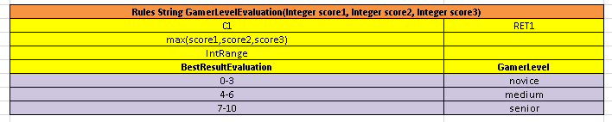
Figure 76: En example of using the ‘max’ function
min/max – returns the smallest or biggest number in a set of numbers (for array, multiple values); the function result is a number.
min/max(number1, number2, …)
min/max(array[]) – you should previously define the array in the given rule table, or in a different table
In the above diagram, the max(score1,score2,score3) expression is used to define the highest result for a player. For example, max(1, 5, 3) gives us ‘5’ as the result; so the player level will be ‘medium’ as defined in the RET1 column.
Sum – adds all numbers in the provided array and returns the result as a number.
sum (number1, number2, …)
sum(array[])
avg – returns the arithmetic average of array elements. The function result is a number.
avg(number1, number2, …)
avg(array[])
product – multiplies the numbers from the provided array and returns the product as a number.
product(number1, number2, …)
product(array[])
mod – returns the remainder after a number is divided by a divisor. The result is a numeric value and has the same sign as the devisor.
mod(number, divisor)
number is a numeric value whose remainder you wish to find;
divisor is the number used to divide the number. If the divisor is ‘0’, then the mod function returns error
sort – returns values from the provided array in ascending sort; the result is also an array
sort(array[])

Date Functions
OpenL Tablets supports a wide range of Date functions that users can apply in their rule tables. The following Date functions return an int Data type:
absMonth – returns the number of months since AD.
absMonth(Date)
absQuarter – returns the number of quarters since AD as an integer value.
absQuarter(Date)
dayOfWeek – takes a Date as input and returns the day of the week on which that date falls; days in a week are numbered from 1 to 7 as follows: 1=Sunday, 2=Monday, 3 = Tuesday, etc.
dayOfWeek(Date d)
dayOfMonth – takes a Date as input and returns the day of the month on which that date falls; days in a month are numbered from 1 to 31.
dayOfMonth(Date d)
dayOfYear – takes a Date as input and returns the day of the year on which that date falls; days in a year are numbered from 1 to 365.
dayOfYear(Date d)
weekOfMonth – takes a Date as input and returns the week of the month within which that date is; weeks in a month are numbered from 1 to 5.
weekOfMonth(Date d)
weekOfYear – takes a Date as input and returns the week of the year on which that date falls; weeks in a year are numbered from 1 to 54.
weekOfYear(Date d)
second – returns the second (0 to 59) for an input Date
second(Date d)
minute – returns the minute (0 to 59) for an input Date
minute(Date d)
hour – the hour of the day in 12 hour format for an input Date
hour(Date d)
hourOfDay – returns the hour of the day in 24 hour format for an input Date
hourOfDay(Date d)
The next Date function returns a String Data type:
amPm(Date d) – returns Am or Pm value for an input Date
amPm(Date d)
The figure below shows values returned by Date functions for a particular input date specified in the MyDate field.
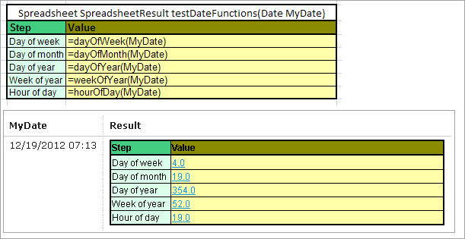
Figure 77: Date functions in OpenL Tablets
The following Decision table provides a very simple example of how the dayOfWeek function can be used when returned value – Risk Factor, – depends on day of week.
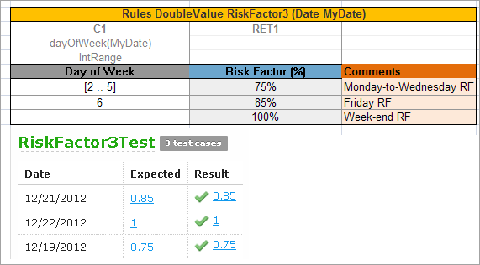
Figure 78: A Risk Factor depends on a day of week

ROUND function
The ROUND function is used to round a value to a specified number of digits. For example, in financial operations you may want to calculate insurance premium with accuracy up to two decimals. Usually we need to limit a number of digits in long data types such as Double Value or BigDecimal. The function allows you to round a value to an integer number or to a fractional number with limited signs after point.
The ROUND function syntax is:
- round(DoubleValue) – rounds to integer number
- round(DoubleValue, int) – rounds to fractional number; int – a number of digits after point
- round(DoubleValue, int, int) – rounds to fractional number and enables you to get results different from usual mathematical rules; in this variant of syntax:
- the first int – a number of digits after point
- the second int – a rounding mode represented by a constant (e.g., 1 – round_DOWN, 4- ROUND_HALF_UP)
round(DoubleValue)
Use this syntax to round to an integer number. The illustration below provides an example of the syntax usage.
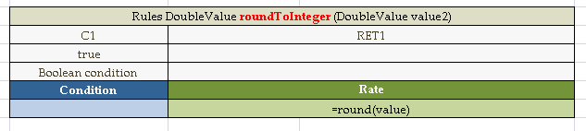
Figure 79: Rounding to integer
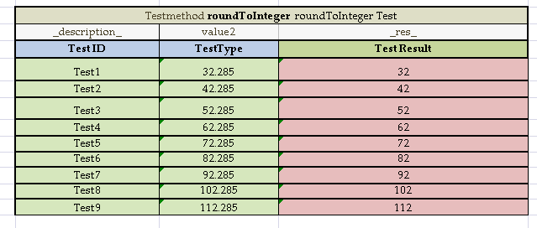
Figure 80: Test table for rounding to integer
round(DoubleValue,int)
You will use this syntax to round to a rounds to fractional number; int – a number of digits after point.
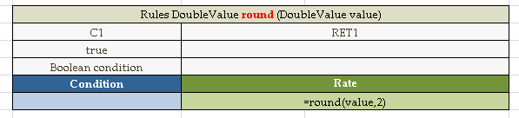
Figure 81: Rounding to a fractional number
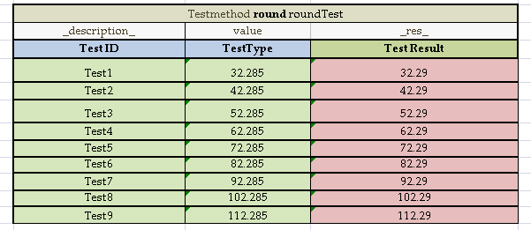
Figure 82: Test table for rounding to a fractional number
round(DoubleValue,int,int)
Enables you to rounds to fractional number and get results different from usual mathematical rules; in this variant of syntax:
- the first int – a number of digits after point
- the second int – a rounding mode represented by a constant (e.g., 1– round_DOWN, 4- ROUND_HALF_UP)
The following table contains a list of the constants and their descriptions.
Constant | Name | Description
0 | ROUND_UP | Rounding mode to round away from zero.
1 | ROUND_DOWN | Rounding mode to round towards zero
2 | ROUND_CEILING | Rounding mode to round towards positive infinity
3 | ROUND_FLOOR | Rounding mode to round towards negative infinity.
4 | ROUND_HALF_UP | Rounding mode to round towards "nearest neighbor" unless both neighbors are equidistant, in which case round up.
5 | ROUND_HALF_DOWN | Rounding mode to round towards "nearest neighbor" unless both neighbors are equidistant, in which case round down.
6 | ROUND_HALF_EVEN | Rounding mode to round towards the "nearest neighbor" unless both neighbors are equidistant, in which case, round towards the even neighbor.
7 | ROUND_UNNECESSARY | Rounding mode to assert that the requested operation has an exact result, hence no rounding is necessary.
For more details on the constants representing rounding modes see http://docs.oracle.com/javase/6/docs/api/constant-values.html#java.math.BigDecimal.ROUND_HALF_DOWN.
You will find detailed description of the constants with examples at http://docs.oracle.com/javase/6/docs/api/java/math/RoundingMode.html, in the Enum Constant Details section.
The following examples show how the rounding works with the ROUND_DOWN constant.
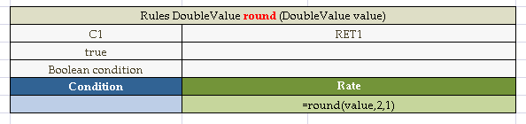
Figure 83: Usage of the ROUND_DOWN constant
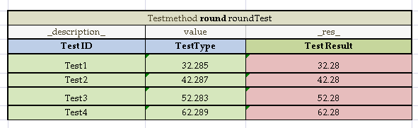
Figure 84: Test table for rounding to fractional number using the ROUND_DOWN constant

Null Elements Usage in Calculations
This section describes how null elements represented as Value Data Types are processed in calculations.
In some calculations e.g. 'a+b' or 'a*b' values ‘a’ and/or ‘b’ can be ‘null’ elements. If one of the calculated values is ‘null’ the following rules are applied.
If one of calculated values is ‘null’ it is recognized as ‘0’ for sum operations or as ‘1’ for multiply operations.
The following diagrams demonstrate these rules.
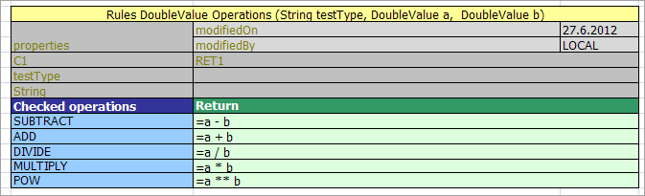
Figure 85: Rules for null elements usage in calculations
The next Test table provides examples of calculations with null values.
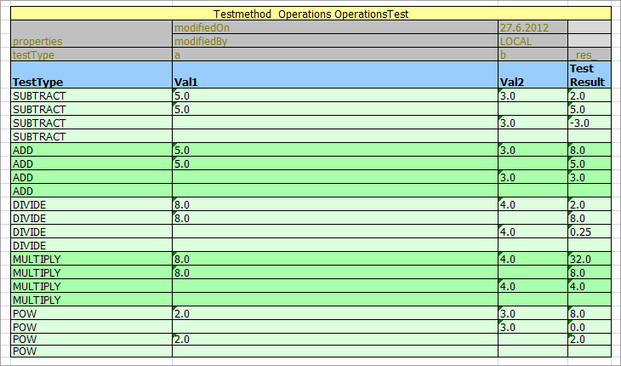
Figure 86: Test table for null elements usage in calculations
NOTE: If all values are ‘null’ the result is also ‘null’.

Chapter 4: OpenL Business Expression Language

OpenL language framework has been designed from the ground to allow flexible combination of grammar and semantics. OpenL Business Expression (BEX) language proves this statement on practice by extending existing OpenL Java grammar and semantics presented in org.openl.j configuration by new grammar and semantic concepts that allow users to write "natural language" expressions.

Java Business Object Model as Basis for OpenL Business Vocabulary
As always, OpenL minimizes the necessary effort required to build a Business Vocabulary. Using of BEX does not require any special mapping, the existing Java BOM automatically becomes the basis for OpenL Business Vocabulary (OBV). For example, the following expressions are equivalent

driver.age
and

Age of the Driver
Another example:

policy.effectiveDate
and

Effective Date of the Policy
As you can see from these examples, if your Java model correctly reflects Business Vocabulary there is no further action needed. In cases where Java Model is not satisfactory you still can apply custom type-safe mapping (renaming) that always have been part of OpenL Framework.

New Keywords, how to avoid possible naming conflicts
In the previous chapter we introduced new ‘of the’ keyword. There are other (self-explanatory) keywords in BEX language:
- is less than
- is more than
- is less or equal
- is no more than
- is more or equal
- is no less than
We plan to add more keywords to OpenL BEX language, and therefore there is a chance of a name clash with Business Vocabulary. The easiest way to avoid this clash is to use upper case notation when referring to the model attributes, because BEX grammar is case-sensitive and all the new keywords will be in the lower case. For example, there is an attribute called isLessThanCoverageLimit. If you refer to it as is less than coverage limit, there is going to be a name clash with the keyword, but if you write Is Less Than Coverage Limit, no clash will appear. The possible direction in extending keywords is to add numerics, measurement units, measure sensitive comparisons, like is longer than or is colder than etc.

Simplifying Expressions with explanatory variables
For example, we have a (not very) complex expression:
In Java:
(vehicle.agreedValue - vehicle.marketValue) / vehicle.marketValue > limitDefinedByUser
In BEX language you can re-write the same expression in a "business-friendly" way:
(Agreed Value of the vehicle - Market Value of the vehicle) / Market Value of the vehicle is more than Limit Defined By User
Unfortunately, the more complex is the expression, the less comprehensible the "natural language" expression becomes. OpenL BEX offers you an elegant solution for this problem:
(A - M) / M > X, where
A - Agreed Value of the vehicle,
M - Market Value of the vehicle,
X - Limit Defined By User
The syntax is pretty similar to the one that have been used in scientific publications and is easily understood by anybody. We believe that the syntax provides the best mix of mathematical clarity and business readability.

Simplifying Expressions by Using Unique in Scope concept
Humans differ from computers, in particular, by their ability to understand the scope of the language expression. For example, if we discuss an insurance policy and mention "the effective date" we don't have to say every time the fully qualifying expression "the effective date of the policy", because the context of the effective date is clearly understood. On another hand, if we discuss two policies, for example, the old and the new ones, we have to say "the effective date of the new policy" vs. "the effective date of the old policy". This is necessary, because there are 2 different policies in the context of the conversation.
Similarly, when humans write so called "business documents" – files that serve as a reference point to a rule developer, they also often use an "implied context" in mind. Therefore they often use in documentation business terms such as Effective Date, Driver, Account etc. with implied scope in mind. The "scope resolution" is left to a so-called Rules Engineer, who has to do it by manually analyzing BOM and setting appropriate paths from the root objects.
OpenL BEX tries to close this semantic gap or at least make it a bit narrower by letting use "unique in scope" attributes. For example, if there is only one policy in the scope, user can write just "effective date" instead of "effective date of the policy". OpenL BEX will automatically determine the uniqueness of the attribute and either produce a correct path, or will emit error message in case of an ambiguous statement. The level of the resolution can be modified programmatically and by default equals to 1.

OpenL Vocabulary and OpenL BEX
Since version 5.0.5 OpenL introduced the ability to augment existing Java BOM with different kind of meta-information through OpenL Vocabulary. As always, we made it accessible through Java API and as Excel tables, giving business users access to the Vocabulary. While Vocabulary can be used for many other important activities, it has one feature that is significant in the context of OpenL BEX – Business Object Attribute Aliasing – or in layman's words, the ability to name attribute with alternative names. This gives to user an ability to adopt existing Java model names to the business terminology in a case when Java model does not reflect it properly. See OpenL Vocabulary for more details.

Future developments, compatibility etc
OpenL BEX is a fairly new development, it will evolve to provide user with new convenient features. In particular, right now there is no other way to call methods in OpenL except for the old-fashioned Java/C++ style. Nevertheless, we want to state that existing syntax will remain compatible with all future modifications. Also, the ability to use Java style constructs together with "natural-language" extensions will stay in the language. And, finally, the last word about using NL references in this document – BEX is NOT a NL-tool, it is just a syntax extension of the standard Java grammar that allows your expressions in many cases look like normal English phrases. The result will be as good as your Java BOM is, BEX would not be able to fix a bad design or naming conventions. We strongly recommend that you at least try it and send us your feedback, it does not require any additional efforts, because BEX is now a standard part of OpenL Tablets. You can use in any place where you previously used Java expressions.

OpenL Programming Language Framework
As we all know, Business Rules consist of rules. Each Rule has Condition and Action. Condition is a boolean expression (the one that returns true or false). Action can be any sequence (usually simple) of programming statements. What kind of language is most suitable for this task?
Let's take a look at the expression that probably is as ubiquitous in any BR doc as "if customer's level is GOLD":
driver.age < 25
From the semantic perspective, the expression intends to define the relationship between some value defined by 'driver.age' expression and literal '25'. One might guess that the English semantic of the statement could be any of if age of the driver is less than 25 years or select drivers who are younger than 25 years old or some other.
From the programming language perspective, the semantic part is irrelevant, the statement should only be:
- a valid statement in the language grammar
- a statement should be correct from the type-checking point of view
- if language is compiled, the valid binary code or some other results of compiling (for example bytecode, or even code in some other target language might also be considered as possible results of the compiling) should be produced from the statement
- some kind of runtime system, interpreter or Virtual Machine should be able to execute (interpret) this statement's compiled code and produce a resulting object

OpenL Grammars
When OpenL parser parses an OpenL expression it produces a Syntax Tree. Each Tree Node has a node type, a literal value, a reference to the source code for displaying errors and debugging, and also may contain children nodes. This is similar to what other parsers do, with one notable exception – the OpenL Grammar is not hard-coded, it can be configured, and different can be used. Having said this, we also must admit that for all the practical purposes, as of today, we distribute only the following grammars implemented in OpenL: org.openl.j – based on "classic" Java 1.3 grammar (no templates and exception handling) and org.openl.bex – which is basically org.openl.j grammar with "business natural language" extensions. The latter is used by default in OpenL Tablets business rules product.
We also have experimental org.openl.n3 grammar and we may add org.openl.sql grammar in the future.
The Syntax Tree produced by the org.openl.j grammar for the expression we started with will look like this:
<
/ \
. 25
/ \
driver age

The node types of the nodes are
- op.binary.lt for '<'
- literal.integer for '25'
- chain for '.'
- identifier for 'driver'
- identifier for 'age'
Node type names are significant, as we will see later, but at this point they look rather like random names.
NOTE. It is also important to recognize that the Grammar we use in org.openl.j is similar not only to Java but to any other language in C/C++/Java/C# family. This makes OpenL easily learned and accepted by the huge pool of available Java/Cxx programmers and adds to it's strength. The proliferation of new languages like Ruby, Groovy, multiple proprietary languages used in different Business Rules Engines, CEP Engines etc., introduced not only the new semantics to the programming community, but also a bunch of new grammars that make the acceptance of the new technologies much harder.
We at OpenL work day and night to stay as close to the Java syntax as possible to make sure that the "entities would not be multiplied beyond necessity". Let's keep the world's linguistic entropy down, folks.

Context, Variables and Types
After the Syntax Tree had been created, the next stage of the compilation process, or Binding, binds syntax nodes to its semantic definitions. At this stage, OpenL uses specific Binders for each node type. The modular structure of OpenL allows to define custom Binders for each node type. Once syntax node had been bound into Bound Node, it has been assigned a type, making the process type-safe.
Most of the time, the standard Java approach is used to assign type to the variable – it should be defined somewhere in the context of the OpenL framework. Typical examples include:
- Method parameter
- Local Variable
- Member of surrounding class (in case of OpenL it is usually the implementation of IOpenClass called Module)
- External types accessed as static, mostly Java classes that are imported into OpenL
Fields and Methods in binding context – this is a feature that does not exist in Java; OpenL allows programmatically add custom types, fields and methods into Binding Context; for different examples of how it could be done you need to take a good look at the source code of OpenLBuilder classes in different packages. For example, org.openl.j automatically imports all the classes from the java.util in addition to the standard java.lang package. Since version 5.1.1 java.math is also being imported automatically

OpenL Type System
Everybody knows that Java is a type-safe language. But it's type-safety ends when Java has to deal with types that lie outside of Java type system – like database tables, http requests or XML files. There are two approaches to deal with those "external" types – use API or use code-generation. API approach is inherently not type-safe, it treats attribute as literal strings, therefore even spelling errors will be visible only in runtime. Another problem with API – it is well, API-specific, so unless the standard API exists, your program becomes dependent on the particular API. The approach with code-generation is better, but it also introduce an extra building step and is dependent on particular generator, especially the part where names and name spaces are converted into Java names and packages. Often, the generators introduce dependencies with runtime libraries that also affect the portability of the code. Finally, generators usually require full conversion from external data into Java objects that may incur an unnecessary performance penalty in the case where you need to access only a few attributes. OpenL Open Type system gives you the simple way to add new types into OpenL language, all you need is to define a class object that implements IOpenClass interface and add it to OpenL type system. The implementations can vary, but access to object's attributes and methods will have the same syntax and will provide the same type-checking in all OpenL code throughout your application.

OpenL Tablets as OpenL Type extension
OpenL Tablets is built on top of OpenL type system, and this allows it to integrate naturally into any Java or OpenL environment. Using OpenL methodology, Decision Tables become Methods, and Data Tables become Fields. The similar conversion happens to all the other project artifacts. It allows for easy modular access to any project's component through Java or OpenL code. An OpenL Tablets project itself becomes a "class" and easy Java access to it is provided through a generated JavaWrapper class.

Operators
Operators are just other methods with priorities defined by the Grammar. OpenL has 2 major types of operators: unary and binary. In addition, there are other operator types used in special cases. Here is a complete list of OpenL operators used in org.openl.j Grammar – the one that is used by default in OpenL Tablets product.
When we say that OpenL has a modular structure, we not only refer to the fact that OpenL has configurable, high-level separate components like Parser and Binder; it is also, that each node type can have its own NodeBinder. At the same time, we can assign the single NodeBinder to a group of operators, like we do in the case of the prefix op.binary.
NOTE: (op.binary.or '||' and op.binary.and '&&' have separate NodeBinders to provide short-circuiting for boolean operands). For all other binary operators OpenL uses a simple algorithm, based on the operator's node type name. For example, if the node type is 'op.binary.add', the algorithm looks for the method named 'add()' in the following order:
- Tx add(T1 p1, T2 p2) in the namespace org.openl.operators in the BindingContext
- public Tx T1.add(T2 p2) in T1
- static public Tx T1.add(T1 p1, T2 p2) in T1
- static public Tx T2.add(T1 p1, T2 p2) in T2
The found method is then being executed in the runtime. So, if you need to override binary operator t1 OP t2 (where t1, t2 are objects of classes T1, T2 ), you need to do the following steps:
- Check the Operators Table and find the operator's type name.
- The last part of the type name will give you the name of the method that you need to implement
- Now you have the following options for implementing operators:
- put it into some class YourCustomOperators as the static method and register the class as the library in org.openl.operators namespace (see OpenLBuilder code for more details).
- implement as method in T1: public Tx name(T2 p2)
- implement as method in T1: static public Tx name(T1 p1,T2 p2)
- implement as method in T2: static public Tx name(T1 p1,T2 p2)
Usually, if T1 and T2 are different, you need to define both OP(T1, T2) and OP(T2, T1), unless you can rely on autocast() operator or Binary Operators' Semantic Map. Autocast can help you skip implementation when you already have an operator implemented for the autocasted type. For example, if you have OP(T1, double), you don't have to implement OP(T1, int), because int is autocasted to double. You may incur some performance penalty by doing this though. Binary Operator Semantic Map is described next.

Binary Operators Semantic Map
Since the version 5.1.1 there is a convenient feature that we call Operator Semantic Map. It makes implementing of some of the operators easier by describing properties (symmetrical and inverse) for some operators.

Unary Operators
For unary operators, the same method resolution algorithm is being applied; the only difference is that there is only one parameter to deal with.

Cast Operators
Cast Operators in general correspond to Java guidelines and come in 2 types: cast and autocast. T2 autocast (T1 from, T2 to) methods used to overload implicit cast operators (like from int to long, so that actually no cast operators are required in code), T2 cast(T1 from, T2 to) methods are used with explicit cast operators.
NOTE: It is important to remember that while both cast() and autocast() methods require 2 parameters, only T1 from parameter will be actually used. The second parameter is needed to avoid ambiguity in Java method resolution

Strict equality and relation operators
Strict operators are same as their original prototypes but they used the strict comparison for float point values. Float point numbers are used in JVM as value with an inaccuracy. The original relation and equality operators are used inaccuracy of float point operations. For example:
1.0 == 1.0000000000000002 – returns true value,
1.0 ==== 1.0000000000000002 (1.0 + ulp(1.0)) – returns false value,
where 1.0000000000000002 = 1.0 + ulp(1.0).

The list of org.openl.j Operators
In the order of priority:
Assignment operators
Operator | org.openl.j operator
= | op.assign
+= | op.assign.add
-= | op.assign.subtract
*= | op.assign.multiply
/= | op.assign.divide
%= | op.assign.rem
&= | op.assign.bitand
|= | op.assign.bitor
^= | op.assign.bitxor

Conditional Ternary
Operator | org.openl.j operator
? : | op.ternary.qmark

Implication
Operator | org.openl.j operator
-> | op.binary.impl ^{(*)}

Boolean OR
Operator | org.openl.j operator
|| or "or" | op.binary.or

Boolean AND
Operator | org.openl.j operator
&& or "and" | op.binary.and

Bitwise OR
Operator | org.openl.j operator
| | op.binary.bitor

Bitwise XOR
Operator | org.openl.j operator
^ | op.binary.bitxor

Bitwise AND
Operator | org.openl.j operator
& | op.binary.bitand

Equality
Operator | org.openl.j operator
== | op.binary.eq
!= | op.binary.ne
==== | op.binary.strict_eq ^{(*)}
!=== | op.binary.strict_ne ^{(*)}

Relational
Operator | org.openl.j operator
< | op.binary.lt
> | op.binary.gt
<= | op.binary.le
>= | op.binary.ge
<== | op.binary.strict_lt ^{(*)}
>== | op.binary.strict_gt ^{(*)}
<=== | op.binary.strict_le ^{(*)}
>=== | op.binary.strict_ge ^{(*)}

Bitwise Shift
Operator | org.openl.j operator
<< | op.binary.lshift
>> | op.binary.rshift
>>> | op.binary.rshiftu

Additive
Operator | org.openl.j operator
+ | op.binary.add
- | op.binary.subtract

Multiplicative
Operator | org.openl.j operator
* | op.binary.multiply
/ | op.binary.divide
% | op.binary.rem

Power
Operator | org.openl.j operator
** | op.binary.pow ^{(*)}

Unary Operators
Operator | org.openl.j operator
+ | op.unary.positive
- | op.unary.negative
++x | op.prefix.inc
--x | op.prefix.dec
x++ | op.suffix.inc
x-- | op.suffix.dec
! | op.unary.not
~ | op.unary.bitnot
(cast) | type.cast
|x| | op.unary.abs ^{(*)}

^{(*)} Operators do not exist in Java Standard, only in org.openl.j, but you can use and overload them at will

The list of opg.openl.j Operator Properties

Symmetrical
eq(T1,T2) <=> eq(T2, T1)
add(T1,T2) <=> add(T2, T1)

Inverse
le(T1,T2) <=> gt(T2, T1)
lt(T1,T2) <=> ge(T2, T1)
ge(T1,T2) <=> lt(T2, T1)
gt(T1,T2) <=> le(T2, T1)

Chapter 5: Working With Projects
OpenL TabletsThis section describes creating an OpenL Tablets project. For general information on projects, see Projects.
The following topics are included in this section:
- Project Structure
- Creating a Project
- Generating a Wrapper

Project Structure
The best way to use the OpenL Tablets rule technology in a solution is to create an OpenL Tablets project in Eclipse. An OpenL Tablets project is a Java project with an OpenL Tablets facet. A typical OpenL Tablets project contains the following general elements:
OpenL Tablets project contents
Element | Description
Main content
Excel files | Physical storage of rules and data in the form of tables.
Additional Java code | Optional classes for domain models and for processing or testing rules in the project. Solution developers can decide whether to include additional code in OpenL Tablets projects.
Additional content
Ant task for generating static wrappers | Ant configuration file used for creating wrapper classes for Excel files so that they can be accessed from code. For general information on wrappers, see Wrappers.
Wrappers | Java classes providing access to OpenL Tablets rules in Excel files. Wrappers are generated as described in Generating a Wrapper.
Third party dependencies | Java libraries files used in rules and Java code.
The following table describes common OpenL Tablets folders in the physical project structure. However, the structure can be adjusted according to the developer’s preferences, for example, to comply with the Maven structure.
Rule projects must contain the default folders rules and gen to be recognized.
OpenL Tablets project structure
Folder | Contents
src | Contains all project Java classes apart from wrappers.
rules | Contains Excel files with rules.
gen | Contains generated wrapper classes.
bin | Contains compiled Java code.
build | Contains Ant configuration file for generating wrapper classes. For information on generating wrappers, see Generating a Wrapper.
libs | Contains rules project dependencies JAR files.

Creating a Project
The simplest way to create an OpenL Tablets project is to add a simple OpenL Tablets in Eclipse to the installed OpenL Tablets Eclipse Update Site.
A new project is created containing simple template files that developers can use as the basis for a custom rule solution.

Generating a Wrapper
Access to rules and data in Excel tables is realized through OpenL Tablets API. OpenL Tablets provides wrappers to developers to facilitate easier usage.
In OpenL Tablets WebStudio, a rule project must have a static wrapper created in the gen folder to be recognized. For general information on wrappers, see Wrappers.
The following topics are included in this section:
- Generating a Dynamic Wrapper
- Using a Dynamic Wrapper in the Run-time Context
- Generating a Static Wrapper
- Example of Using a Static and Dynamic Wrapper

Generating a Dynamic Wrapper
Only an interface must be defined when creating a project for a dynamic wrapper. OpenL Tablets users can clearly define rules displayed in the application by using this interface. Using dynamic wrappers is a recommended practice.
This section illustrates the creation of a dynamic wrapper for a Simple project in Eclipse with the OpenL Tablets Eclipse Update Site installed. Only one rule hello1 is created in the Simple project by default.
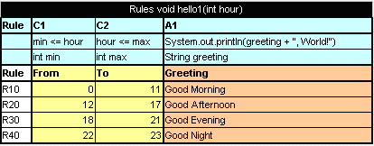

Figure 87: The hello1 rule table
Proceed as follows:
- In the project src folder, create an interface as follows:
public interface simple {
void hello1(int i);
}
- Create a class for a wrapper as follows:
package template;

import static java.lang.System.out;
import org.openl.rules.runtime.RuleEngineFactory;
public class Dynamic_wrapper {

public static void main(String[] args) {
//define the interface
RuleEngineFactory<simple> rulesFactory = new RuleEngineFactory<simple>("rules/TemplateRules.xls", simple.class);

simple rules = rulesFactory.newInstance();
rules.hello1(12);

}

}

When the class is run, it executes and displays Good Afternoon, World!

Using a Dynamic Wrapper in the Run-time Context
This section describes the use of the run-time context for dispatching rules by dimension properties values, when rules are overloaded by properties.
For example, consider two rules overloaded by dimension properties. Both rules have the same name.
The first rule, covering an auto policy, follows:
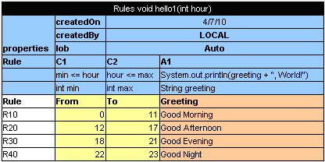

Figure 88: The auto policy rule
The second rule, covering a homeowner policy, follows:
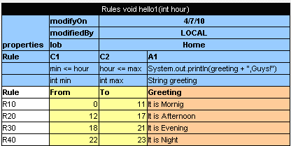

Figure 89: The homeowner policy rule
A dynamic wrapper enables the user to identify which of these rules must be executed.

// Getting runtime environment which contains context
IRuntimeEnv env = ((IEngineWrapper<simple>) rules).getRuntimeEnv();

// Creating context
IRulesRuntimeContext context = new DefaultRulesRuntimeContext();
env.setContext(context);
// define context
context.setLob("Home);
As a result, the code of the dynamic wrapper with the run-time context resembles the following:
import static java.lang.System.out;

import org.openl.rules.context.DefaultRulesRuntimeContext;
import org.openl.rules.context.IRulesRuntimeContext;
import org.openl.rules.runtime.RuleEngineFactory;
import org.openl.runtime.IEngineWrapper;
import org.openl.vm.IRuntimeEnv;
public class Dynamic_wrapper {

public static void main(String[] args) {
//define the interface
RuleEngineFactory<simple> rulesFactory = new RuleEngineFactory<simple>("rules/TemplateRules.xls", simple.class);
simple rules = rulesFactory.newInstance();
// Getting runtime environment which contains context
IRuntimeEnv env = ((IEngineWrapper<simple>) rules).getRuntimeEnv();
// Creating context (most probably in future, the code will be different)
IRulesRuntimeContext context = new DefaultRulesRuntimeContext();

env.setContext(context);
context.setLob("Home");
rules.hello1(12);

}

}
Run this class. In the console, ensure that the rule with lob = Home was executed. With the input parameter int = 12, the It is Afternoon, Guys phrase is displayed.

Generating a Static Interface
Since OpenL 5.9.3 it is possible to generate a java interface wrapper over the rules. The generation is performed by the org.openl.conf.ant.JavaInterfaceAntTask ant task. For more information, please see the sections:
- Configuring the Ant Task File to learn how to configure an Ant task file.
- Executing the Ant Task File to learn how to execute an Ant task file.

The only thing that should be done is to change the name of the ant task in your GenerateJavaWrapper.build.xml from org.openl.conf.ant.JavaWrapperAntTask to org.openl.conf.ant.JavaInterfaceAntTask.
During the generation process, the rules.xml file will be created in the project root folder, and java interface will be generated in the location specified in the Ant task. For more information about configuring rules.xml see OpenL Tablets – Developer Guide, the Rules project descriptor section.
It is more preferable to generate a Static Interface rather than a Static Wrapper.

Generating a Static Wrapper
To generate a static wrapper class, proceed as follows:
- Configure the Ant task file as described in Configuring the Ant Task File.
- Execute the Ant task file as described in Executing the Ant Task File.
For an example of how to use a static and dynamic wrapper, see Example of Using Static and Dynamic Wrappers.

Configuring the Ant Task File
When a new OpenL Tablets project is created, it already contains an Ant task file GenerateJavaWrapper.build.xml located in the build folder. When the file is executed, it automatically creates wrapper Java classes for specified Excel files. The Ant task file must be adjusted to match contents of the specific project.
For each Excel file, an individual <openlgen> section must be added between the <target> and </target> tags.
Each <openlgen> section has a number of parameters that must be adjusted. The following table describes <openlgen> section parameters:
Parameters in the <openlgen> section
Parameter | Description
openlName | OpenL configuration to be used. For OpenL Tablets, the following value must always be used:  org.openl.xls
userHome | Location of user defined resources relative to the current OpenL Tablets project.
srcFile | Reference to the Excel file for which a wrapper class must be generated.
targetClass | Full name of the wrapper class to be generated.  OpenL Tablets WebStudio recognizes modules in projects by wrapper classes and uses their names in the user interface. If there are multiple wrappers with identical names, only one of them is recognized as a module in OpenL Tablets WebStudio.
displayName | End user oriented title of the file that appears in OpenL Tablets WebStudio.
targetSrcDir | Folder where the generated wrapper class must be placed.
The following is an example of the GenerateJavaWrapper.build.xml file:
<project name="GenJavaWrapper" default="generate" basedir="../">
<taskdef name="openlgen" classname="org.openl.conf.ant.JavaWrapperAntTask"/>

<target name="generate">
<echo message="Generating wrapper classes..."/>

<openlgen openlName="org.openl.xls" userHome="."
srcFile="rules/Rules.xls"
targetClass="com.exigen.claims.RulesWrapper"
displayName="Rule table wrapper"
targetSrcDir="gen"
>
</openlgen>

<openlgen openlName="org.openl.xls" userHome="."
srcFile="rules/Data.xls"
targetClass=" com.exigen.claims.DataWrapper"
displayName="Data table wrapper"
targetSrcDir="gen"
>
</openlgen>

</target>
</project>

Executing the Ant Task File
To execute the Ant task file and generate wrappers, proceed as follows:
- In Eclipse, refresh the project.
- Execute the Ant task XML file as an Ant build.
- Refresh the project again so that wrapper classes are displayed in Eclipse.
Once wrappers are generated, the corresponding Excel files can be used in the solution.

Example of Using a Static and Dynamic Wrapper
The following example illustrates the use of static and dynamic wrappers:
public class Tutorial1Main {

public interface Tutorial1Rules {
void hello1(int i);
}

public static void main(String[] args)
{
out.println("\n* OpenL Tutorial 1\n");

out.println("Working using static wrapper...\n");

callRulesWithStaticWrapper();

out.println("\nWorking using dynamic wrapper...\n");

callRulesWithDynamicWrapper();

}

private static void callRulesWithStaticWrapper() {
//Get current hour
Calendar calendar = Calendar.getInstance();
int hour = calendar.get(Calendar.HOUR_OF_DAY);

//Creates new instance of Java Wrapper for our lesson
Tutorial_1Wrapper tut1 = new Tutorial_1Wrapper();

//Step 1
out.println("* Executing OpenL rules...\n");

// Call the method wrapping Decision Table "hello1"
tut1.hello1(hour);
}

private static void callRulesWithDynamicWrapper(){

// Creates new instance of OpenL Rules Factory
RuleEngineFactory<Tutorial1Rules> rulesFactory = new RuleEngineFactory<Tutorial1Rules>("rules/Tutorial_1.xls", Tutorial1Rules.class);

//Creates new instance of dynamic Java Wrapper for our lesson
Tutorial1Rules rules = rulesFactory.newInstance();

//Get current hour
Calendar calendar = Calendar.getInstance();
int hour = calendar.get(Calendar.HOUR_OF_DAY);

out.println("* Executing OpenL rules...\n");
rules.hello1(hour);
}
}

Rules Runtime Context
OpenL Tablets supports rules overloading by metadata (table properties). What is this? Sometimes user needs business rules that work differently but have the same inputs.
Let’s imagine that you provide vehicle insurance and have a premium calculation rule for it. For example, the algorithm of premium calculation is following:

PREMIUM = RISK_PREMIUM + VEHICLE_PREMIUM + DRIVER_PREMIUM - BONUS
For different US states you have different bonus calculation policies. In simple way for all the states you must have different calculations:
PREMIUM_1 = RISK_PREMIUM + VEHICLE_PREMIUM + DRIVER_PREMIUM - BONUS_1, for state #1
PREMIUM_2 = RISK_PREMIUM + VEHICLE_PREMIUM + DRIVER_PREMIUM - BONUS_2, for state #2
...
PREMIUM_N = RISK_PREMIUM + VEHICLE_PREMIUM + DRIVER_PREMIUM - BONUS_N, for state #N
OpenL Tablets provides more elegant solution for this case.

PREMIUM = RISK_PREMIUM + VEHICLE_PREMIUM + DRIVER_PREMIUM - BONUS*

BONUS_1, for state #1
BONUS_2, for state #2
...

BONUS_N, for state #N
So you have one common premium calculation rule and several different rules for bonus calculation. When you run the premium calculation rule you should provide current state as additional input for OpenL Tablets to choose the appropriate rule. Using this information OpenL Tablets makes decision which bonus method should be used (invoked). This kind of information is called runtime data and should be set into runtime context before you run the calculations.
The following OpenL table snippets show our sample in action:
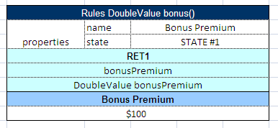
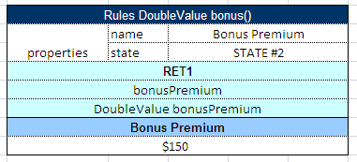
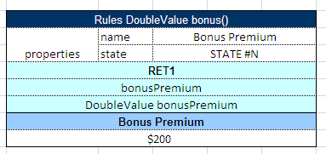

Figure 90: The group of Decision Tables overloaded by properties
All tables for bonus calculation have the same declaration but different state property value.
OpenL Tablets has predefined runtime context which already has several properties.

Using Rules Runtime Context in Java Code

OpenL Tablets static java wrapper
The following code snippet demonstrates how can be used rules runtime context and his variables in application.
...
TestWrapper wrapper = new TestWrapper();
IRulesRuntimeContext context = wrapper.getRuntimeContext();

Calendar calendar = Calendar.getInstance();
calendar.set(2003, 5, 15);
context.setCurrentDate(calendar.getTime());

DoubleValue res1 = wrapper.driverRiskScoreOverloadTest("High Risk Driver");
...

Rules engine factory
Rules engine factory provides method that returns runtime context only when your interface extends IRulesRuntimeContextProvider interface.
public interface ITestI extends IRulesRuntimeContextProvider {
DoubleValue driverRiskScoreOverloadTest(String driverRisk);
}
The following code snippet demonstrates how can be used rules runtime context and his variables in application.
...
File xlsFile = new File("RulesContextTest.xls");
EngineFactory engineFactory = new RuleEngineFactory(xlsFile, ITestI.class);
ITestI instance = engineFactory.newInstance();

IRulesRuntimeContext context = instance.getRuntimeContext();

Calendar calendar = Calendar.getInstance();
calendar.set(2003, 5, 15);
context.setCurrentDate(calendar.getTime());

DoubleValue res1 = instance.driverRiskScoreOverloadTest("High Risk Driver");
...

Managing Rules Runtime Context from Rules
There is a possibility to work with runtime context from OpenL Tablets rules. It is provided by the following additional internal methods for modification, retrieving and restoring runtime context:
- getContext(): returns copy of the current runtime context.
- emptyContext() : returns new empty runtime context.
- setContext(IRulesRuntimeContext context) : replaces current runtime context by the specified.
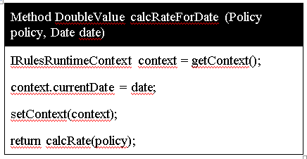
- modifyContext(String propertyName, Object propertyValue) : modifies current context by one property: adds new or replaces by specified if property with such a name already exists in current context. Note: all properties from current context will be available after modification, so it is only one property update.
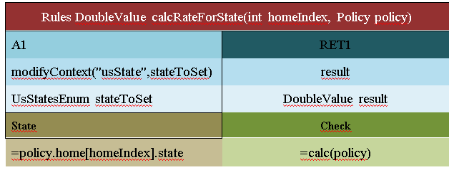
- restore() : discharges the last changes in runtime context. It means that context will be rolled back to the state before the last setContext or modifyContext.
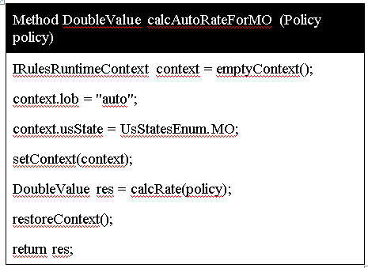
ATTENTION: You should control all changes and rollbacks manually: all changes applied to runtime context will remain after the execution of the rule is completed. So you should make sure that the changed context is restored after the rule had been executed to prevent unexpected behavior of rules caused by unrestored context.

Module dependencies
Dependency feature allows including one module to another by its name. It is done for more flexibility and convenience. For example user has several projects with different modules, all his projects share the same domain model or use similar helpers methods, so to avoid rules duplication, user can put his common rules and data to separate module and add this module as dependency for all modules where it is needed.

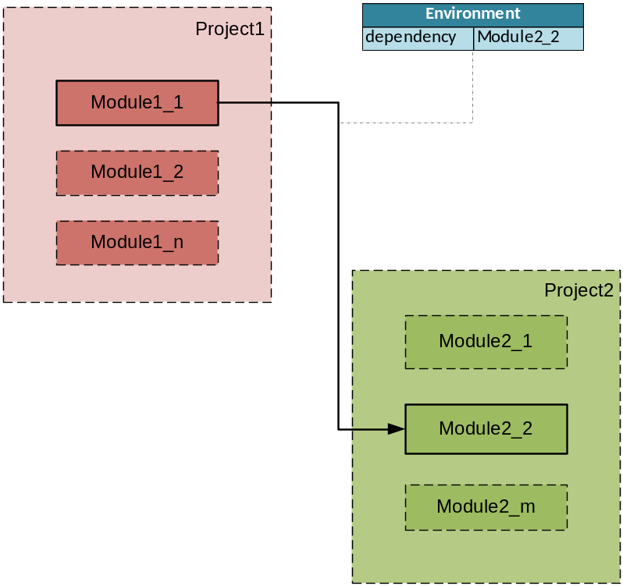

Figure 91: Example of including one module to another as dependency
To add dependency to module, simply add the instruction to Environment table, use command dependency and the name of the module you want to add. Module can contain any number of dependencies. Dependency modules may also have dependencies. Avoid cyclic dependencies.
When OpenL is processing module, if there is any dependency declaration, it tries to load and compile it first before root module. When all required dependencies have been successfully compiled, OpenL compiles root module itself with awareness about rules and data from dependencies.

Glossary
Root module – the module that has dependency declaration to other module.
Dependency module – the module that is used as a dependency.
Bundle classloader (e.g. dependency classloader) – java classloader that was used for compiling the dependency module.

Functionality description
After adding a dependency, all its methods, data fields, datatypes are accessible from root module. The dependency knows nothing about the fact some module is using it.
Root module can call dependency rules (Figure 66). All methods are accessible from outside, so the user of this infrastructure knows nothing about which method is from root project and which is from dependency.
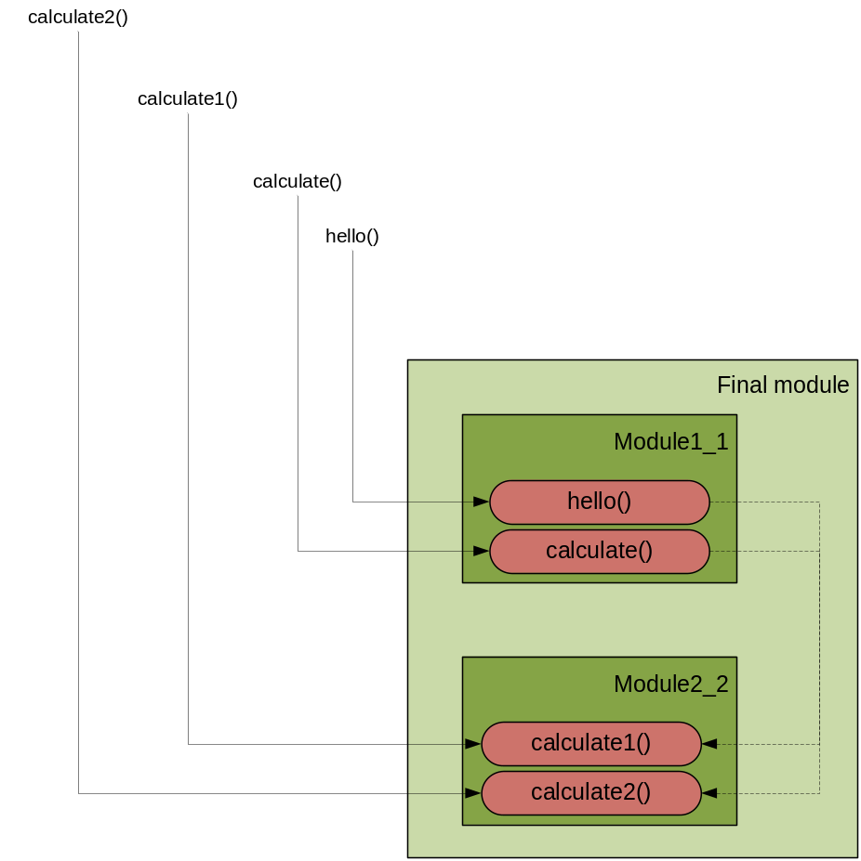

Figure 92: Using rules from dependency module

Components behavior
All OpenL components can be divided into 3 types:
- Rules or Methods (Decision table, Spreadsheet, Method, TBasic, etc)
- Data or Data fields (Data table)
- Datatypes or Java beans (Datatype table)
The table below describes the behavior of different OpenL components in dependency infrastructure.

Components  Operations | Methods | Datatypes | Data fields
Can access components in root module from dependency | yes | yes | yes
Both root and dependency modules contain similar component | - Methods with the same signature and without dimension properties: methods will be wrapped by Method Dispatcher, no errors at compile time. Ambiguous method exception will be thrown at runtime.  - Methods with the same signature and with a number of dimension properties: they will be wrapped by Method Dispatcher. At runtime will be executed method that matches the runtime context properties.  - Methods with the same signature and with property active: only one table can be set to true (appropriate validation will check this case at compile time). | Duplicate exception | The field from the root module will be used
None of root and dependency modules contain the component | There is no such method exception while compilation | There is no such datatype exception while compilation | There is no such field exception while compilation

Appendix A: BEX Language Overview
This section provides a general overview of the BEX language that can be used in OpenL Tablets expressions.
The following topics are included in this section:
- Introduction to BEX
- Keywords
- Simplifying Expressions

Introduction to BEX
BEX language allows a flexible combination of grammar and semantics by extending the existing Java grammar and semantics presented in the org.openl.j configuration using new grammar and semantic concepts. It enables users to write expressions similar to natural human language.
BEX does not require any special mapping; the existing Java business object model automatically becomes the basis for open business vocabulary used by BEX. For example, Java expression 'policy.effectiveDate' is equivalent with BEX expression 'Effective Date of the Policy'.
If the Java model correctly reflects business vocabulary, there is no further action required. In case the Java model is not satisfactory, custom type-safe mapping or renaming can be applied.

Keywords
The following table represents BEX keyword equivalents to Java expressions:
BEX keywords
Java expression | BEX equivalents
== | - equals to  - same as
!= | - does not equal to  - different from
a.b | b of the a
< | is less than
> | is more than
<= | - is less or equal  - is in
!> | is no more than
>= | is more or equal
!< | is no less than
Because of these keywords, name clashes with business vocabulary can occur. The easiest way to avoid clashes is to use upper case notation when referring to model attributes because BEX grammar is case sensitive and all keywords are in lower case.
For example, assume there is an attribute called isLessThanCoverageLimit. If it is referred as 'is less than coverage limit', a name clash with keywords 'is less than' occurs. The workaround is to refer to the attribute as 'Is Less Than Coverage Limit'.

Simplifying Expressions
Unfortunately, the more complex an expression is, the less comprehensible the natural language expression becomes in BEX. For this purpose, BEX provides the following methods for simplifying expressions:
- Notation of Explanatory Variables
- Uniqueness of Scope

Notation of Explanatory Variables
BEX supports a notation where an expression is written using simple variables followed by the attributes they represent. For example, assume the following expression is used in Java:
(Agreed Value of the vehicle - Market Value of the vehicle) / Market Value of the vehicle is more than Limit Defined By User
As can be seen from the example, the expression is hard to read. However, the expression is much simpler if written according to the notion of explanatory variables as follows:

(A - M) / M > X, where
A - Agreed Value of the vehicle,
M - Market Value of the vehicle,
X - Limit Defined By User
This syntax is similar to the one used in scientific publications and is much easier to read for complex expressions. It provides a good mix of mathematical clarity and business readability.

Uniqueness of Scope
BEX provides another way for simplifying expressions using the concept of unique scope. For example, if there is only one policy in the scope of expression, the user can write 'effective date' instead of 'effective date of the policy'. BEX automatically determines the uniqueness of the attribute and either produces a correct path or emits an error message in case of ambiguous statement. The level of the resolution can be modified programmatically and by default equals 1.

Appendix B: Functions Used in OpenL Tablets
This section provides a complete list of functions available in OpenL Tablets.

Math Functions
Math Functions
Function | Description | Comment
abs(a) | Returns the absolute value of a number.
acos(double a) | Returns the arc cosine of a value; the returned angle is in the range 0.0 through pi.
asin(double a) | Returns the arc sine of a value; the returned angle is in the range -pi/2 through pi/2.
atan(double a) | Returns the arc tangent of a value; the returned angle is in the range -pi/2 through pi/2.
atan2(double y, double x) | Returns the angle theta from the conversion of rectangular coordinates (x, y) to polar coordinates (r, theta).
cbrt(double a) | Returns the cube root of a double value.
ceil(double a) | Returns the smallest (closest to negative infinity) double value that is greater than or equal to the argument and is equal to a mathematical integer.
copySign(magnitude, sign) | Returns the first floating-point argument with the sign of the second floating-point argument.
cos(double a) | Returns the trigonometric cosine of an angle.
cosh(double x) | Returns the hyperbolic cosine of a double value.
cosh(double x) | Returns the hyperbolic cosine of a double value.
exp(double a) | Returns Euler's number e raised to the power of a double value.
expm1(double x) | Returns ex -1
floor(double a) | Returns the largest (closest to positive infinity) double value that is less than or equal to the argument and is equal to a mathematical integer.
format(double d) | Formats double value.
format(double d, String fmt) | Formats double value according to Formatn fmt.
getExponent(a) | Returns the unbiased exponent used in the representation of a.
getExponent(double x, double y) | Returns sqrt(x2 +y2) without intermediate overflow or underflow.
IEEEremainder(double f1, double f2) | Computes the remainder operation on two arguments as prescribed by the IEEE 754 standard.
log(double a) | Returns the natural logarithm (base e) of a double value.
log10(double a) | Returns the base 10 logarithm of a double value.
log1p(double x) | Returns the natural logarithm of the sum of the argument and 1.
nextAfter(start, direction) | Returns the floating-point number adjacent to the first argument in the direction of the second argument.
pow(double a, double b) | Returns the value of the first argument raised to the power of the second argument.
quotient(number, divisor) | Returns the quotient from division number by divisor.
random() | Returns a double value with a positive sign, greater than or equal to 0.0 and less than 1.0.
remove(array [] , int index) | Removes the element at the specified position from the specified array.
removeElement(array [], element) | Removes the first occurrence of the specified element from the specified array.
rint(double a) | Returns the double value that is closest in value to the argument and is equal to a mathematical integer.
round(value) | Returns the closest value to the argument, with ties rounding up.
round(value, int scale, int roundingMethod) | Returns a BigDecimal whose scale is the specified value, and whose unscaled value is determined by multiplying or dividing this BigDecimal's unscaled value by the appropriate power of ten to maintain its overall value.
scalb(a, int scaleFactor) | Return a × 2scaleFactor rounded as if performed by a single correctly rounded floating-point multiply to a member of the double value set.
signum(double d) / (float f) | Returns the signum function of the argument; zero if the argument is zero, 1.0 if the argument is greater than zero, -1.0 if the argument is less than zero.
sin(double a) | Returns the trigonometric sine of an angle.
sinh(double x) | Returns the hyperbolic sine of a double value.
sqrt(double a) | Returns the correctly rounded positive square root of a double value.
tan(double a) | Returns the trigonometric tangent of an angle.
tanh(double x) | Returns the hyperbolic tangent of a double value.
toRadians(double angdeg) | Converts an angle measured in degrees to an approximately equivalent angle measured in radians.
ulp(value) | Returns the size of an ulp of the argument.

Array Functions
Array Functions
Function | Description | Comment
add(array[],element) | Copies the given array and adds the given element at the end of the new array.
add(array[],index, element) | Inserts the specified element at the specified position in the array.
addAll(array1[], array2[]) | Adds all the elements of the given arrays into a new array.
addIgnoreNull(array[], element) | Copies the given array and adds the given element at the end of the new array.
addIgnoreNull(array[], int index, element) | Inserts the specified element at the specified position in the array.
allTrue(boolean[] values)  allTrue(Boolean[] values) | Returns true if all array elements are true.
anyTrue(boolean[] values)  anyTrue(Boolean[] values) | Returns true if any array element is true.
avg(array[]) | Returns the arithmetic average of array elements as a number.
big(array[], int position) | Removes null values from array, sorts an array in descending order and returns the value at position 'position'.
contains(array[], elem) | Checks if the value is in the given array.
indexOf(array[], elem) | Finds the index of the given value in the array.
isEmpty(array[]) | Checks if an array is empty or null.
product(array [] values) | Multiplies the numbers from the provided array and returns the product as a number.
removeNulls(T[] array) | Return a new array without null elements.
slice(Array[], int startIndexInclusive, int endIndexExclusive) | Returns a part of array from startIndexInclusive to endIndexExclusive.
small(Array[], int position) | Removes null values from array, sorts an array in ascending order and returns the value at position 'position'.
sort(Array[]) | Sorts the specified array of values into ascending order, according to the natural ordering of its elements.

Date Functions
Date / Time Functions
Function | Description | Comment
absMonth(Date) | Returns the number of months since AD.
absQuarter(Dat) | Returns the number of quarters since AD as an integer value.
amPm(Date d) | Returns Am or Pm value for an input Date  as a String
dateToString(Date date) | Converts a date to the String.
dateToString(Date date, dateFormat) | Converts a date to the String according dateFormat.
dayDiff(Date d1, Date d2) | Returns the difference in days between endDate and startDate.
firstDateOfQuarter(int absQuarter) | Returns the first date of quarter.
lastDateOfQuarter(int absQuarter) | Returns the last date of the quarter.
lastDayOfMonth(Date d) | Returns the last date of the month.
minute(Date d) | Returns the minute.
monthDiff(Date d1, Date d2) | Return the difference in months before d1 and d2.
nextAfter(Date d) | Returns the floating-point value adjacent to d in the direction of positive infinity.
weekDiff(Date d1, Date d2) | Returns the difference in weeks between endDate and startDate.
yearDiff(Date d1, Date d2) | Returns the difference in years between endDate and startDate.
year(Date d) | Returns the year (0 to 59) for an input Date

String Functions
String Functions
Function | Description | Comment
contains(String str, char searchChar) | Checks if String contains a search character, handling null.
contains(String str, String searchStr) | Checks if String contains a search String, handling null.
containsAny(String str, char[] chars) | Checks if the String contains any character in the given set of characters.
containsAny(String str, String searchChars) | Checks if the String contains any character in the given set of characters.
endsWith(String str, String suffix) | Check if a String ends with a specified suffix.
isEmpty(String str) | Checks if a String is empty ("") or null.
lowerCase(String str) | Converts a String to lower case.
removeEnd(String str, String remove) | Removes a substring only if it is at the end of a source string, otherwise returns the source string.
removeStart(String str, String remove) | Removes a substring only if it is at the beginning of a source string, otherwise returns the source string.
replace(String str, String searchString, String replacement) | Replaces all occurrences of a String within another String.
replace(String str, String searchString, String replacement, int max) | Replaces a String with another String inside a larger String, for the first max values of the search String.
startsWith(String str, String prefix) | Check if a String starts with a specified prefix.
substring(String str, int beginIndex) | Gets a substring from the specified String. | A negative start position can be used to start n characters from the end of the String.
substring(String str, int beginIndex, int endIndex) | Gets a substring from the specified String. | A negative start position can be used to start/end n characters from the end of the String.
upperCase(String str) | Converts a String to upper case.

Error Handling Functions
Error Handling Functions
Function | Description | Comment
error(String msg) | Shows the error message.

Index

A
aggregated object
definition, 47
specifying data, 47
ant task file
configuring, 96
executing, 97
B
BEX language, 106
explanatory variables, 107
introduction, 106
keywords, 106
simplifying expressions, 107
unique scope, 107
Boolean values
representing, 40
C
calculations
using in table cells, 42
configuration table, 54
D
data integrity, 49
data table
advanced, 46
definition, 45
simple, 45
data type table
definition, 43
date values
representing, 40
decision table
definition, 29
interpretation, 34, 36
structure, 30
transposed, 38
E
examples, 11, 13
G
guide
audience, 6
related information, 6
typographic conventions, 6
M
method table
definition, 54
O
OpenL Tablets
advantages, 8
basic concepts, 8
creating a project, 92
definition, 8
installing, 11
introduction, 8
project, 9
rules, 9
tables, 9
wrapper, 9
OpenL Tablets, 14
OpenL Tablets project
definition, 9
P
project
creating, 92, 93
definition, 9
structure, 92
R
rule
definition, 9
run table
definition, 53
structure, 53
S
system overview, 10
T
table cells
using calculations, 42
test table
definition, 50
structure, 51
tutorials, 11
W
wrapper
definition, 9
generating, 93

